PROJECT REPORT

ON

Clothing E-commerce website

SUBMITTED BY

Mr. Yash Rajesh Haria

For Partial Fulfillment for Degree of

Bachelor of Science (Computer Science)

2018-2019

HEAD OF DEPARTMENT PROJECT GUIDE

Prof. SWATI MAURYA Prof. SWATI MAURYA

S.K.Somaiya Degree College Of Arts, Science And Commerce

ACKNOWLEDGEMENT

I have great pleasure in presenting this project entitled "Clothing Ecommerce website" and I grab this opportunity to convey my immense regards towards all the people who with their

invaluable contributions made this project successful.

It gives me great pleasure in presenting this project report.

I also owe to my family and friends who have been a constant source of help to solve the problems that cropped up during the development of the project, positive criticism, suggestions, constant support, encouragement and guidance force towards the successful completion of the project.

# 

# 

# INDEX

|  |  |  |  |
| --- | --- | --- | --- |
| Serial No. |  | Contents | Page |
| 1 |  | Introduction |  |
|  | 1.1 | Description of current system |  |
|  | 1.2 | Limitations of Current System |  |
|  | 1.3 | Proposed system & its Advantages |  |
|  | 1.4 | Front End & Back End |  |
| 2 |  | Feasibility study |  |
|  | 2.1 | Operational Feasibility |  |
|  | 2.2 | Technical Feasibility |  |
|  | 2.3 | Economical Feasibility |  |
| 3 |  | Requirement analysis |  |
|  | 3.1 | Stakeholder |  |
|  | 3.2 | Fact Finding Techniques |  |
|  | 3.3 | Gantt Chart |  |
| 4 |  | System design |  |
|  | 4.1 | Entity relationship Diagram |  |
|  | 4.2 | Event Table |  |
|  | 4.3 | Use Case Diagram |  |
|  | 4.4 | Activity Diagram |  |
|  | 4.5 | Class Diagram |  |
|  | 4.6 | Object Diagram |  |
|  | 4.8 | State Chart Diagram |  |
|  | 4.9 | Package Diagram |  |
| 5 |  | Menu tree |  |
| 6 |  | List of attributes and tables |  |
| 7 |  | Program description |  |
| 8 |  | Validation |  |
| 9 |  | Coding |  |
| 10 |  | Screen layouts |  |
| 11 |  | Bibliography |  |

Introduction

Clothing is the basic nessecity of man. On occasions like Wedding, Vacation, and tour outside and on many other occasion they feel the necessity of man to feel comfortable look good as well as feel good. So Creating a Clothing Ecommerce website would be benificial for everyone anywhere. Now a days, by some clicks only, we can get whatever you want at home. We already know about the online shopping, e-banking etc. Similarly, The clothing Ecommerce will is the online facility to buy clothes online within few clicks only. Some people cannot waste their time traveling to a place then trying on clothes everywhere, it comsumes a lot of time, so for those people this Website becomes very helpful. This website includes various category of clothes, as per the customer order and comfort, it place the order and deliver the product as per the location within the area. Booking is done via internet.It is a system design specially for mens, womens clothes selling business. The Website provides complete functionality of listing and ordering clothes. In this system, Cart facility is also provide.

A Ecommerce website helps the user to view all sort of items at their place of comfort. Ordering through an Ecommerce website helps you to get the product at your doorstep without going to the actual store. The individual who needs a clothes must contact a store and then try the clothes and then purchase the product, This website makes this process easy and simpler.

This website increases customer retention and simplify product management.

⦁ Current System

Some people donot have time to go to the shops to buy clothes, so if they go to bu the clothes they need to travel to the shop and then tr on and then buy the product and then again travel back so this wastes a lot of time . On occasions like Wedding, Vacation, and tour outside and on many other situations they feel the necessity to look good on that occasions . So because of these reasons Ecommerce website come to help and it benefits the customer and the product provider as well.

⦁ Limitations

⦁ Only online payment no Cash on Delivery .

⦁ No return no refund.

⦁ In the existing system you cannot provide feedback of the user to the admin .

—

⦁ Proposed System

The advancement in Information Technology and internet penetration has greatly enhanced various business processes and communication between companies (services provider) and their customers of which Clothing website is not left out. This Clothing Ecommerce Website is developed to provide the following services:

⦁ Enhance Business Processes: To be able to use internet technology to project

the products company to the global world instead of limiting their services to their local domain alone, thus increase their return on investment (ROI).

⦁ Online Shopping : A tools through which customers can buy available clothes online on particular date.

⦁ Customer’s registration: A registration portal to hold customer’s details, monitor their transaction and used same to offer better and improve services to them ⦁ Multiple orders: Allows the customer to order Multiple products at a time.

Clothes a the basic necessity of a man clothes define a person . Clothes are the basic necessity the individual dress according the occasion like wedding, party, vacation etc so clothes are much needed. The individual who needs Clothes goes to the store try the clothes and then buy them.

This website increases customer retention and simplify product and staff management.

Specific goals are –

⦁ To produce a web-based system that allow customer to register and buy clothes online and for the company to effectively sell them.

⦁ To ease customer’s task whenever they need to get some clothes.

Advantages of Clothing Ecommerce Website

⦁ This Ecommerce Website is fully functional and flexible.

⦁ It is very easy to use.

⦁ This Ecommerce Website helps in back office administration by streamlining and standardizing the procedures.

⦁ It saves a lot of time, money and labor.

⦁ The website acts as an office that is open 24/7.

⦁ It increases the efficiency of the management at offering quality services to the customers.

⦁ It provides custom features development and support with the website .

⦁ Software & Hardware Requirements

⦁ Hardware

|  |  |
| --- | --- |
| RAM | 512 MB |
| Harddisk | 10 GB |
| Processor | 1.0 GHz |

Client side:

|  |  |
| --- | --- |
| RAM | 1 GB |
| Harddisk | 20 GB |
| Processor | 2.0 GHz |

Server side:

⦁ Software

|  |  |
| --- | --- |
| Framework | PHP |
| Database Server | Phpmyadmin |
| Web Browser | Internet Explorer 6 or any compatible browser |
| Operating System | Windows or any equivalent OS |

Feasibility Study

A feasibility study assesses the operational, technical and economic merits of the proposed project. The feasibility study is intended to be a preliminary review of the facts to see if it is worthy of proceeding to the analysis phase. From the systems analyst perspective, the feasibility analysis is the primary tool for recommending whether to proceed to the next phase or to discontinue the project.The feasibility study is a management-oriented activity. The objective of a feasibility study is to find out if an information system project can be done and to suggest possible alternative solutions.Projects are initiated for two broad reasons:

1. Problems that lend themselves to systems solutions
2. Opportunities for improving through: (a) upgrading systems (b) altering systems (c) installing new systems

A feasibility study should provide management with enough information to decide:

* Whether the project can be done
* Whether the final product will benefit its intended users and organization
* What are the alternatives among which a solution will be chosen
* Is there a preferred alternative

2.1 TECHNICAL FEASIBILITY

A large part of determining resources has to do with assessing technical feasibility. It considers the technical requirements of the proposed project. The technical requirements are then compared to the technical capability of the organization. The systems project is considered technically feasible if the internal technical capability is sufficient to support the project requirements. The analyst must find out whether current technical resources can be upgraded or added to in a manner that fulfills the request under consideration. This is where the expertise of system analysts is beneficial, since using their own experience and their contact with vendors they will be able to answer the question of technical feasibility.

2.2 OPERATIONAL FEASIBILITY

Operational feasibility is dependent on human resources available for the project and involves projecting whether the system will be used if it is developed and implemented.Operational feasibility is a measure of how well a proposed system solves the problems, and takes advantage of the opportunities identified during scope definition and how it satisfies the requirements identified in the requirements analysis phase of system development.Operational feasibility reviews the willingness of the organization to support the proposed system. This is probably the most difficult of the feasibilities to gauge. In order to determine this feasibility, it is important to understand the management commitment to the proposed project. If the request was initiated by management, it is likely that there is management support and the system will be accepted and used. However, it is also important that the employee base will be accepting of the change.

2.3 ECONOMIC FEASIBILITY

Economic analysis could also be referred to as cost/benefit analysis. It is the most frequently used method for evaluating the effectiveness of a new system. In economic analysis the procedure is to determine the benefits and savings that are expected from a candidate system and compare them with costs. If benefits outweigh costs, then the decision is made to design and implement the system. An entrepreneur must accurately weigh the cost versus benefits before taking an action.The concerned business must be able to see the value of the investment it is pondering before committing to an entire system study. If short-term costs are not overshadowed by long-term gains or produce no immediate reduction in operating costs, then the system is not economically feasible, and the project should not proceed any further. If the expected benefits equal or exceed costs, the system can be judged to be economically feasible. Economic analysis is used for evaluating the effectiveness of the proposed system.

The economical feasibility will review the expected costs to see if they are in-line with the projected budget or if the project has an acceptable return on investment. At this point, the projected costs will only be a rough estimate. The exact costs are not required to determine economic feasibility. It is only required to determine if it is feasible that the project costs will fall within the target budget or return on investment. A rough estimate of the project schedule is required to determine if it would be feasible to complete the systems project within a required timeframe. The required timeframe would need to be set by the organization.

Requirement Analysis

3.1 Stakeholders

Stakeholder refers to any person or group who will be affected by the system (web site) directly or indirectly. Stakeholders include end-users who interact with the system and everyone else that may be affected by its installation. To identify the stakeholders we consulted with expected user, existing employees and owners.

⦁ What functionalities are you expecting to see in Clothing Ecommerce Website ?

⦁ What kind of information to be available to the outsiders?

⦁ What do you think about the security issues of the website?

⦁ What problems do you face now, that you want to automate?

⦁ If you demand for any personal profile what information do you want there?

⦁ How do you want to communicate with other users?

⦁ How do you want to access your result and its visibility to others?

⦁ [External] What information you want to know?

⦁ [Admin] Describe the internal system of Clothing Ecommerce Website .

Concluding thoughts on Stakeholders, We identified following stakeholders for our Web site:

⦁ User (internal/external)

⦁ Requirements engineer

⦁ Developer

⦁ Designer

⦁ Clothing Ecommerce Website staffs

3.2 Fact Finding Techniques

Most of the car rental services are manage using manual way and it cause a lot of problems to its users and also few clients will rent from them. With the born of Car Rental Management System (CRMS), car rental service will be upgraded because it provides convenient to its user. this is actually an ICT business. It is a business because it combines the technology with business. It used Information Technology to manage and record car rentals. So, it also can be called technology because it is developed as a web based application and it changes the manual way into computerized system.

3.3 Gantt Chart

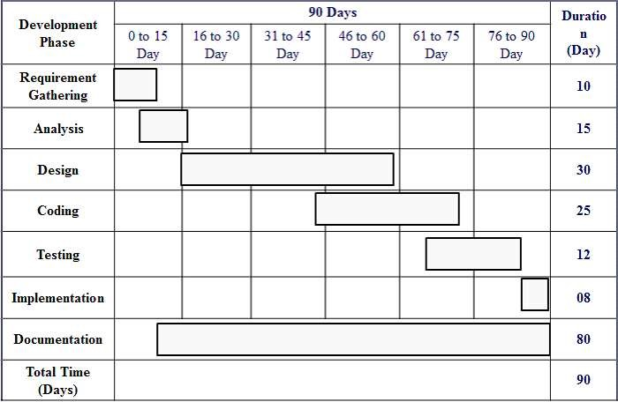

System Design 4.1 Entity Relationship Diagram:

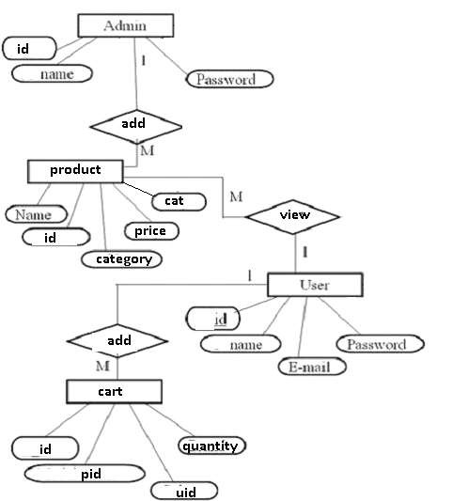

4.2 Event Table:

|  |  |  |  |  |  |  |
| --- | --- | --- | --- | --- | --- | --- |
| No. | Events | Trigger | Source | Activity | Response | destination |
| 1 | Admin adds the product details | New product  Entry | Admin | Adds the details of product | product details | product page |
| 2 | Search | Clients make request | Client | Look up | Product details | Project page |
| 3 | Registration | Request for registration | Client | Register account | Register for account | User page |
| 4 | Add to cart | Request for addition off product | Client | add the product | add the request of product | cart page |
| 5 | Delete product from cart | deletion | client | Update | product removed | user |
| 6 | Logout | Logout action | user | logging out | logged out | index |

4.3 Use Case Diagram:

Use case for Admin:

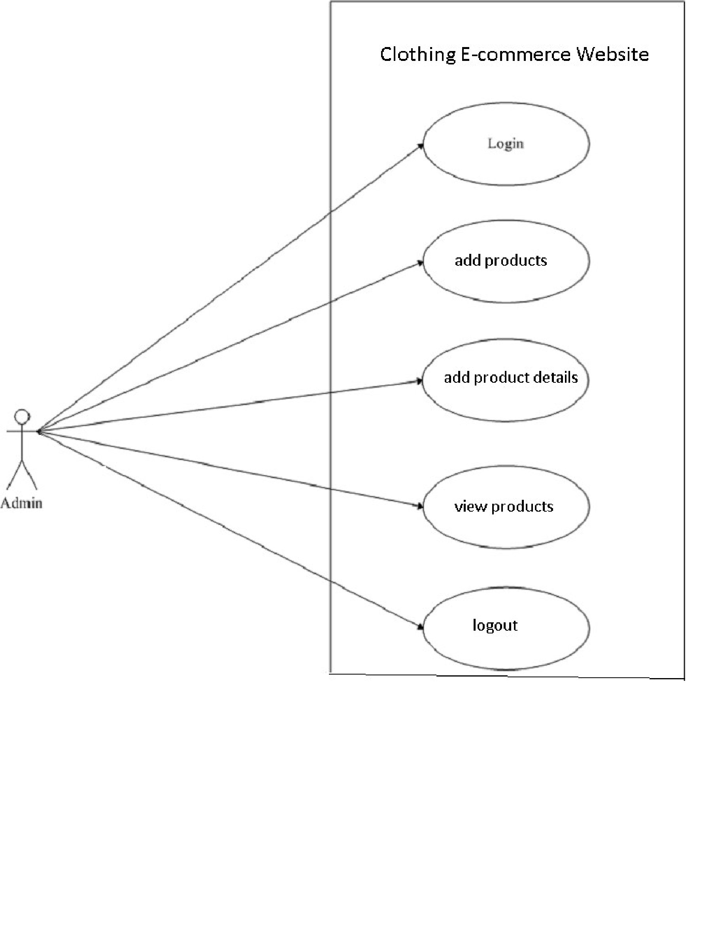

Use case for User:

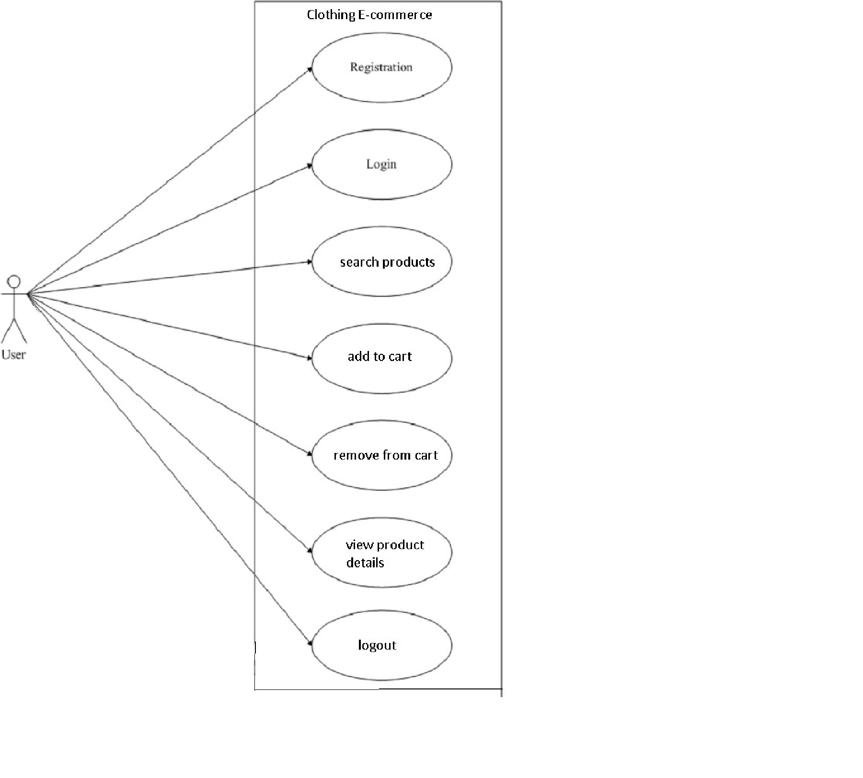

4.4 Activity Diagram:

Activity Diagram for Admin

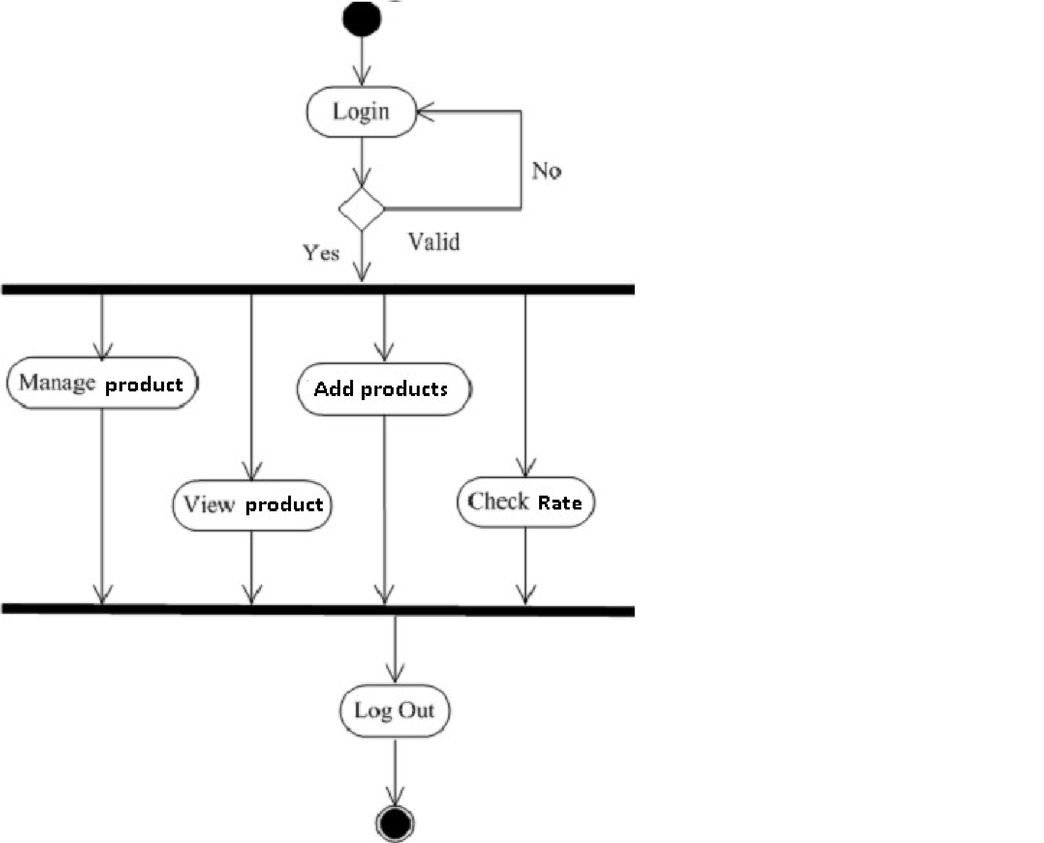

Activity Diagram for User:

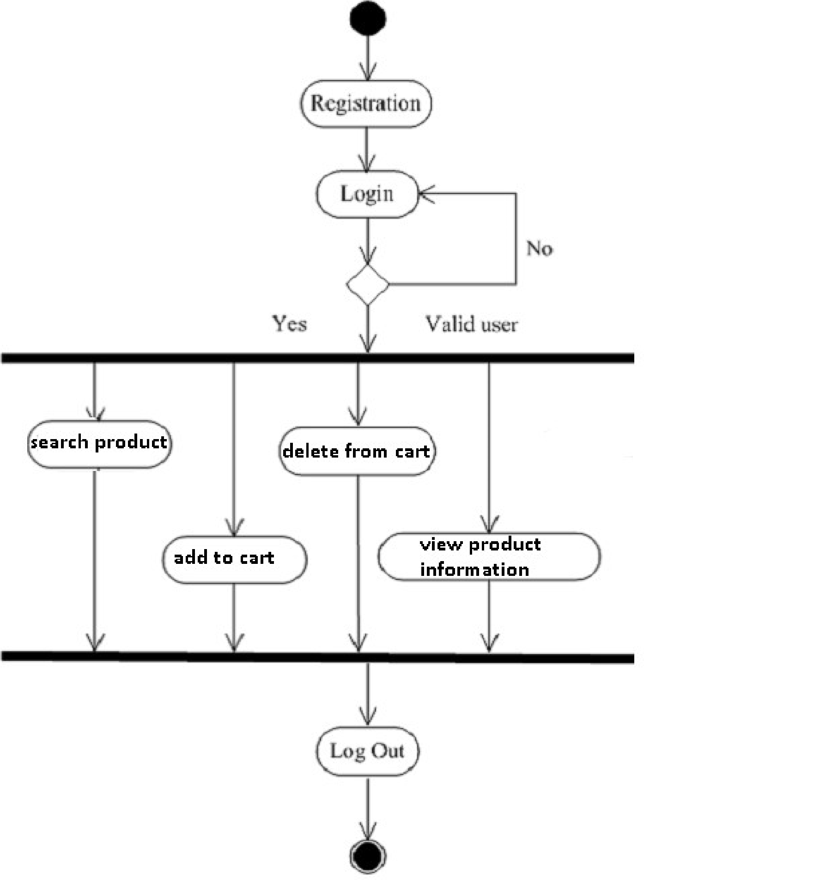

4.5 Class Diagram:

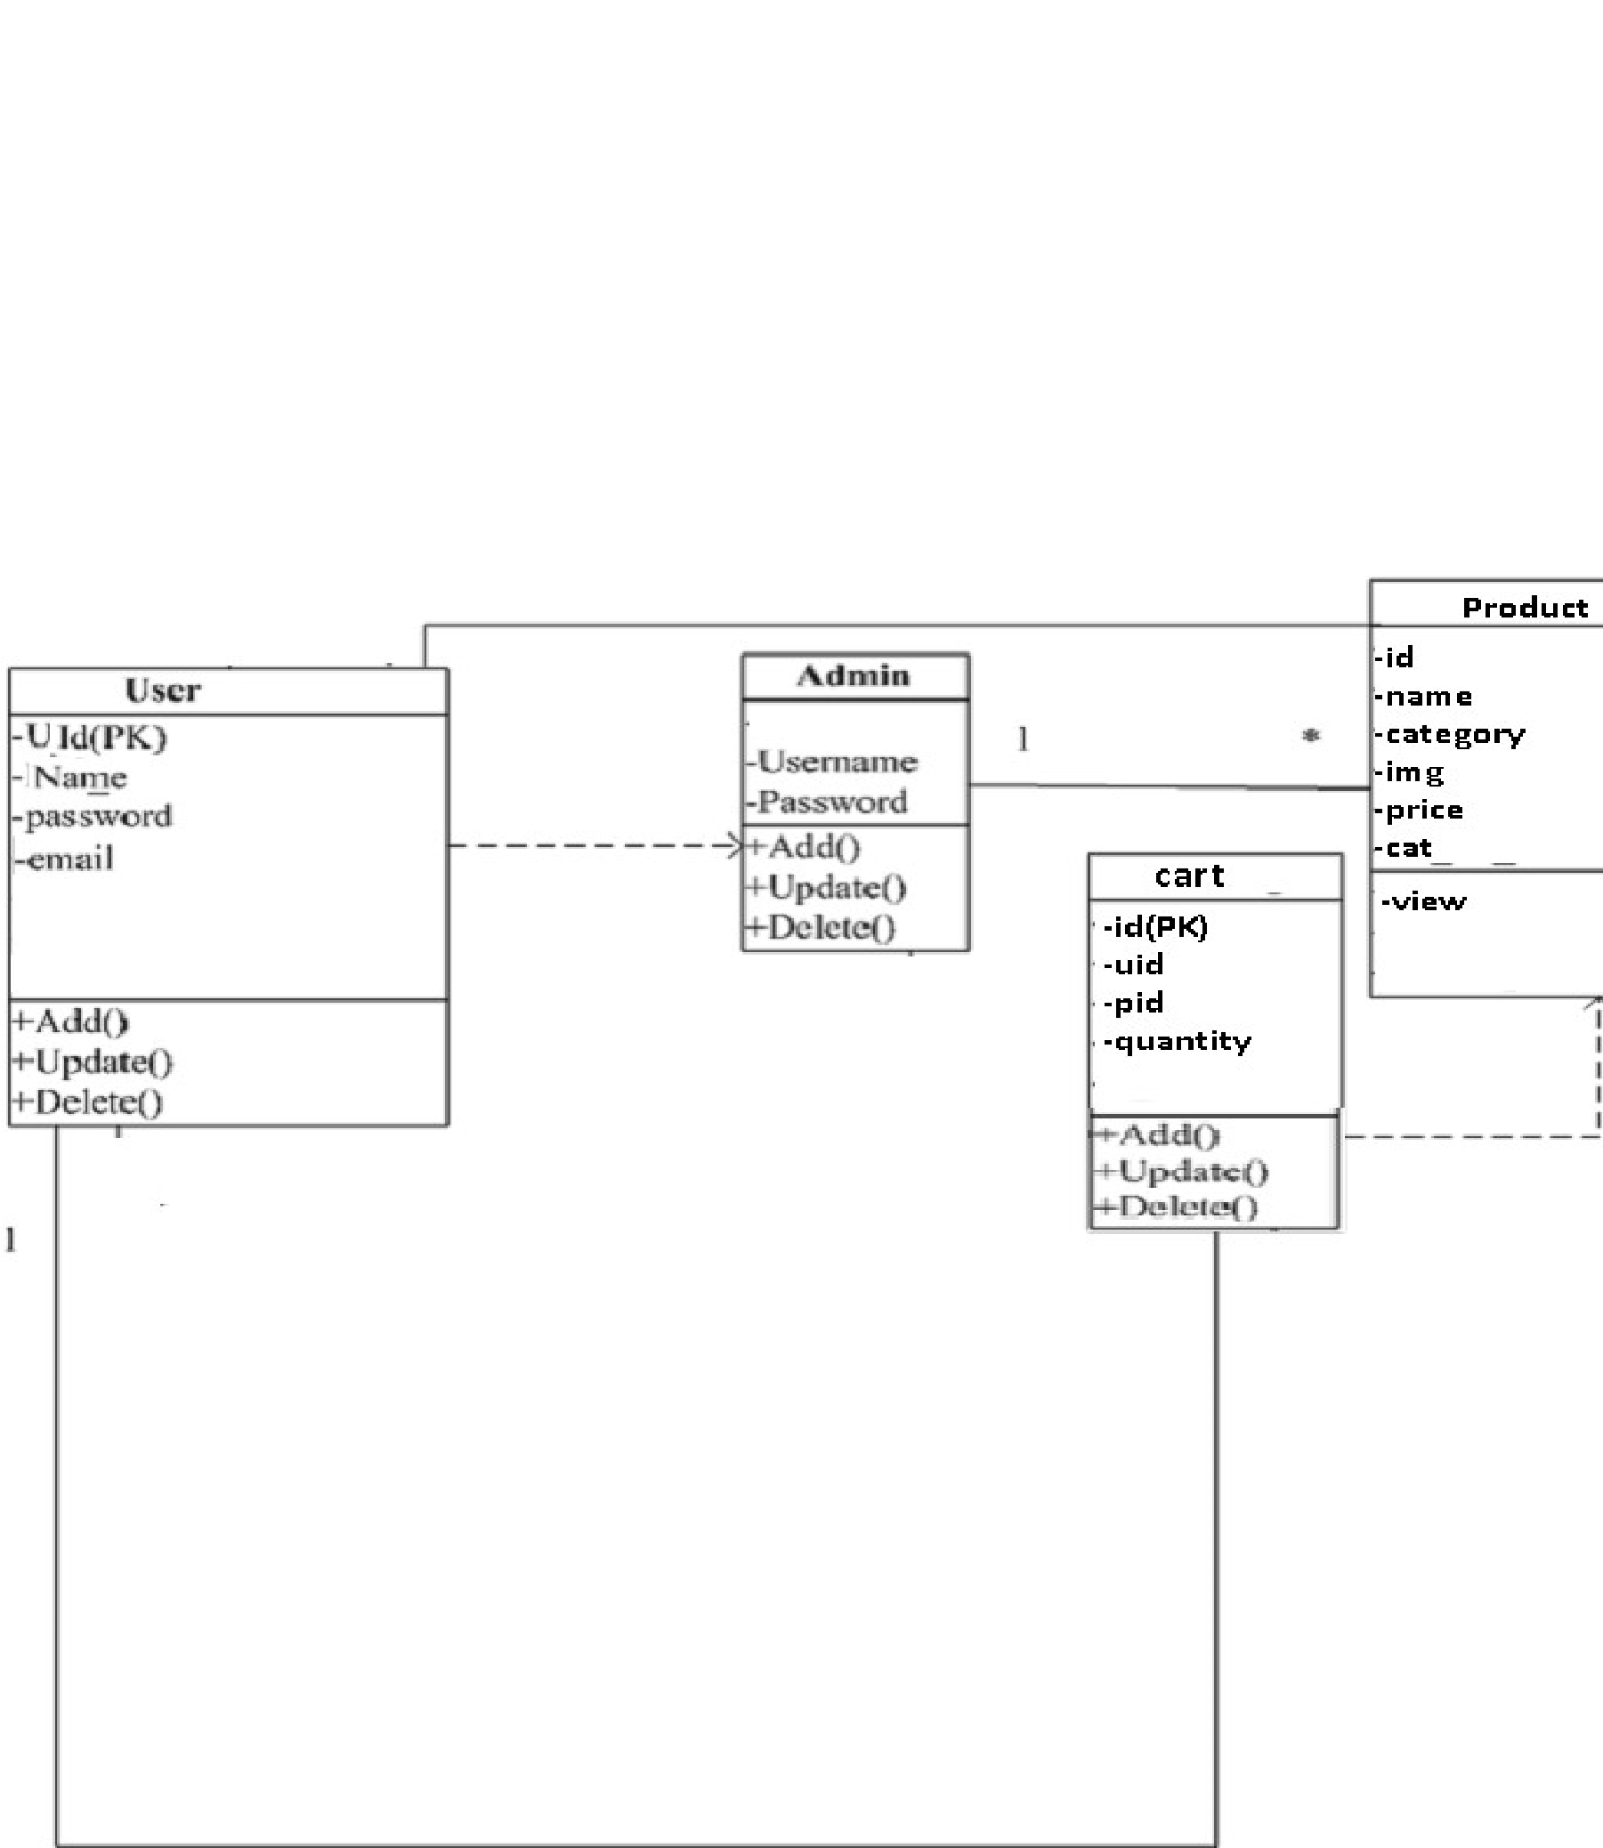

4.6 Object Diagram:

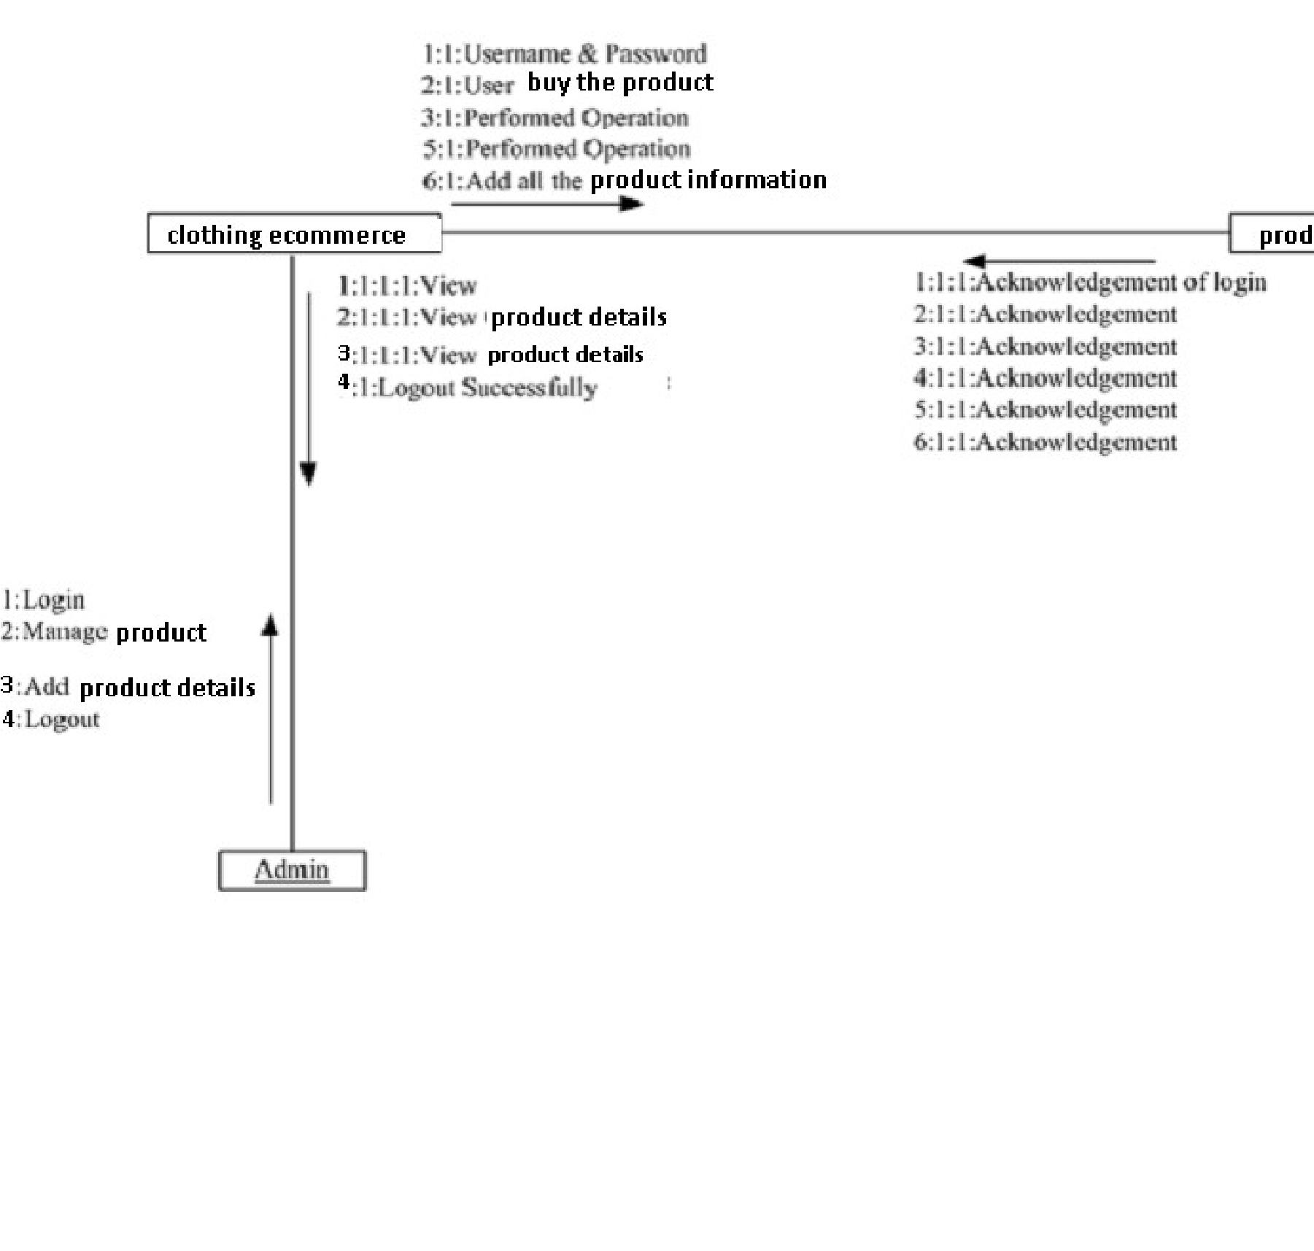

4.9 Package Diagram:

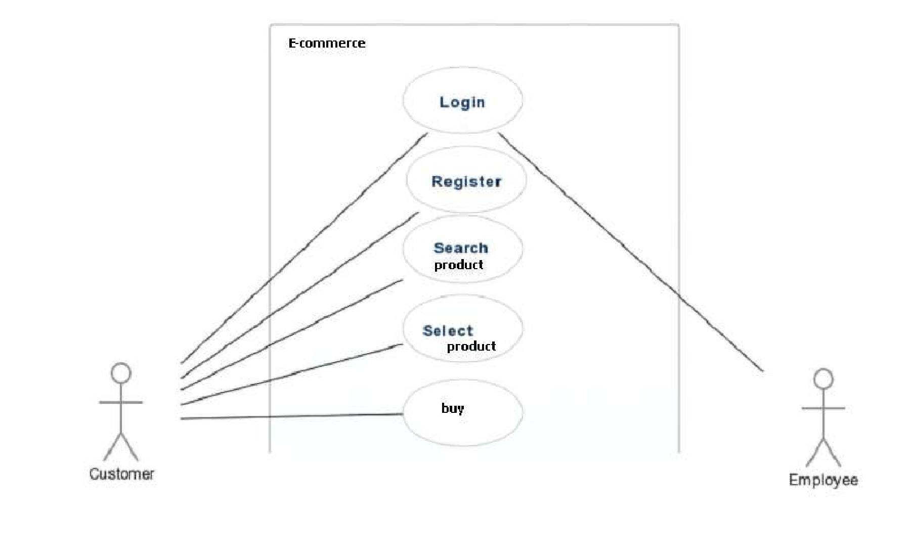

Data Table

Users :

Table Name : users

Description : stores information about users

|  |  |  |  |
| --- | --- | --- | --- |
| Sr. No | Field Name | Data Type | Constraints |
| 1 | id | Int | Primary Key |
| 2 | firstname | Varchar(50) | Not Null |
| 3 | lastname | Varchar(50) | Not Null |
| 4 | email | Varchar(100) | Not Null |
| 5 | password | Varchar(20) | Not Null |

Product Table:

Table Name : product

Descriptions : Stores information about product

|  |  |  |  |
| --- | --- | --- | --- |
| Sr. No | Field Name | Data Type | Constraints |
| 1 | id | Int | Primary Key |
| 2 | name | Varchar(50) | Not Null |
| 3 | category | Varchar(50) | Not Null |
| 4 | img | Varchar(100) | Not Null |
| 5 | Price | Int | Not Null |
| 7 | cat | Varchar(10) | Not Null |

Cart Table:

Table Name : cart

Descriptions : provides the information about cart

|  |  |  |  |
| --- | --- | --- | --- |
| Sr. No | Field Name | Data Type | Constraints |
| 1 | id | int | Primary Key |
| 2 | uid | int | Not Null |
| 3 | pid | int | Not Null |
| 4 | quantity | int | Not Null |

## Program Description

Cart and Order:

⦁ The system must allow the customer to register for buying the product.

⦁ The system shall allow the customer to view detail description of particular product.

⦁ The system shall present an option to browse the product by category of men and women.

⦁ The system must allow the customers to select specific product.

⦁ The system shall allow the customers to remove the product from the cart.

⦁ The system shall allow the admin to insert product.

⦁ The system shall presents information on products and their costs.

Log in:

⦁ The system should allow admin to login to the system using their username and password.

⦁ The system should allow user to login to the system using their username and password.

⦁ The system shall allow the user to create new user account.

⦁ The system shall allow user to logout.

⦁ The system shall allow admin to logout.

Product:

⦁ The system should allow admin to register new products.

⦁ The system shall allow customer to select products.

## Validations

Admin Login:

|  |  |  |  |
| --- | --- | --- | --- |
|  | Field Name |  | Validation |
| Username |  | Not Null |  |
| Password |  | Not Null |  |

User Login:

|  |  |  |  |
| --- | --- | --- | --- |
|  | Field Name |  | Validation |
| Username |  | Not Null |  |
| Password |  | Not Null |  |

**Coding**

**index.php**

<!DOCTYPE html>

<html>

<head>

  <title>Eppareles</title>

  <meta charset="utf-8">

  <meta name="viewport" content="width=device-width, initial-scale=1">

  <title>Epparels</title>

  <link href="//maxcdn.bootstrapcdn.com/bootstrap/4.1.1/css/bootstrap.min.css" rel="stylesheet" id="bootstrap-css">

  <script src="//maxcdn.bootstrapcdn.com/bootstrap/4.1.1/js/bootstrap.min.js"></script>

  <script src="//cdnjs.cloudflare.com/ajax/libs/jquery/2.2.4/jquery.min.js"></script>

  <link href="./css/style.css" rel="stylesheet">

  <title></title>

</head>

<body>

  <?php include 'header.php';?>

  <!--Image Slider-->

  <div class="container">

  <div id="demo" class="carousel slide" data-ride="carousel">

<!-- Indicators -->

<ul class="carousel-indicators">

<li data-target="#demo" data-slide-to="0" class="active"></li>

<li data-target="#demo" data-slide-to="1"></li>

<li data-target="#demo" data-slide-to="2"></li>

</ul>

<!-- The slideshow -->

<div class="carousel-inner">

<div class="carousel-item active">

<img src="./images/clothes2.jpg" alt="Los Angeles">

</div>

<div class="carousel-item">

<img src="./images/clothes2.jpg" alt="Chicago">

</div>

<div class="carousel-item">

<img src="./images/clothes2.jpg" alt="New York">

</div>

</div>

<!-- Left and right controls -->

<a class="carousel-control-prev" href="#demo" data-slide="prev">

<span class="carousel-control-prev-icon"></span>

</a>

<a class="carousel-control-next" href="#demo" data-slide="next">

<span class="carousel-control-next-icon"></span>

</a>

</div>

  </div>

<div class="Epparels-content">

  <div class="container-fluid">

    <div class="row">

        <div class="col-sm-1">

        </div>

<!--gird--><!--Right side-->

        <figure>

        <div class="col-sm-5">

          <a href="mens-products.php"><img class="center img-responsive" src="./images/mens.jpg"></a>

          <div class="carousel-caption">

          <h6 class="display-2">Mens</h6>

        </div>

        </div>

      </figure>

          <figure>

        <div class="col-sm-6">

          <a href="womens-products.php"><img class="center img-responsive" src="./images/womens.jpg" ></a>

          <div class="carousel-caption">

          <h6 class="display-2">Womens</h6>

        </div>

      </div>

    </figure>

    </div>

</div>

</div><!--Epparels-conternt close-->

<!--Welcome -->

<div class="container-fluid padding">

  <div class="row welcome text-center">

    <div class="col-12">

      <h1 class="display-4">Epparel</h1>

    </div>

    <hr>

    <div class="col-12"><p class="lead">Clothing Ecommerce</p></div>

  </div>

</div>

<?php include 'footer.php';?>

</body>

</html>

**mens-products.php**

<?php include 'connection.php';?>

<!DOCTYPE html>

<html>

<head>

    <title>Products</title>

    <meta charset="utf-8">

    <meta name="viewport" content="width=device-width, initial-scale=1">

    <link href="//maxcdn.bootstrapcdn.com/bootstrap/4.1.1/css/bootstrap.min.css" rel="stylesheet" id="bootstrap-css">

    <script src="//maxcdn.bootstrapcdn.com/bootstrap/4.1.1/js/bootstrap.min.js"></script>

    <script src="//cdnjs.cloudflare.com/ajax/libs/jquery/2.2.4/jquery.min.js"></script>

    <link href="./css/style.css" rel="stylesheet">

    <link href="./css/style.css" rel="stylesheet">

    <title></title>

</head>

<body>

    <?php include 'header.php';?>

    <!--Image Slider-->

    <div id="slides" class="carousel slide" data-ride=carousel>

        <ul class="carousel-indicators">

            <li data-target="#slides" data-slide-to="0" class="active"></li>

            <li data-target="#slides" data-slide-to="1"></li>

            <li data-target="#slides" data-slide-to="2"></li>

        </ul>

        <div class="carousel-inner">

            <div class="carousel-item active">

                <img src="./images/clothes2.jpg">

                <div class="carousel-caption">

                    <h1 class="display-2">Epparels</h1>

                    <h3>Trending</h3>

                    <button type="button" class="btn btn-primary btn-lg">Buy Now</button>

                </div>

            </div>

            <div class="carousel-item">

                <img src="./images/clothes2.jpg">

            </div>

            <div class="carousel-item">

                <img src="./images/clothes2.jpg">

            </div>

        </div>

    </div>

<!--Content-->

<div class="Epparels-content">

    <div class="container-fluid">

        <div class="row">

                <div class="col-lg">

                    <div class="row">

                        <?php

                            $q="select * from product where cat='men'";

                            $run=mysqli_query($link,$q);

                            while($row=mysqli_fetch_array($run))

                            {

                                $id=$row['id'];

                                $name=$row['name'];

                                $img=$row['img'];

                                $price=$row['price'];

                        ?>

                        <div class="col-md-3"><?php

                            echo "<figure class='card card-product'>

                                <div class='img-wrap'>

                                    <img src='product-img/$img'>

                                </div>";?>

                                <figcaption class='info-wrap'>

                                    <?php echo"<h6 class='title text-dots'><a href='#'>$name</a></h6>";?>

                                    <div class='action-wrap'>

                                        <a href='b.php?product=<?php echo $id;?>' class='btn btn-primary btn-sm float-right'> Order </a>

                                        <div class='price-wrap h6'>

                                            <?php echo"<span class='price-new'>$price</span>";?>

                                            <!--<del class='price-old'>$1980</del>-->

                                        </div> <!-- price-wrap.// -->

                                    </div> <!-- action-wrap -->

                                </figcaption>

                            </figure> <!-- card // -->

                        </div> <!-- col // -->

                    <?php

                }

                ?>

</div>

                </div>

            </div>

    </div>

</div><!--Epparels-conternt close-->

<!--Welcome -->

<div class="container-fluid padding">

    <div class="row welcome text-center">

        <div class="col-12">

            <h1 class="display-4">Clothes</h1>

        </div>

        <hr>

        <div class="col-12"><p class="lead">Welcome to my website</p></div>

    </div>

</div>

<?php include 'footer.php';?>

</body>

</html>

**Womens-product.php**

<?php include 'connection.php';?>

<!DOCTYPE html>

<html>

<head>

    <title>Products</title>

    <meta charset="utf-8">

    <meta name="viewport" content="width=device-width, initial-scale=1">

    <link href="//maxcdn.bootstrapcdn.com/bootstrap/4.1.1/css/bootstrap.min.css" rel="stylesheet" id="bootstrap-css">

    <script src="//maxcdn.bootstrapcdn.com/bootstrap/4.1.1/js/bootstrap.min.js"></script>

    <script src="//cdnjs.cloudflare.com/ajax/libs/jquery/2.2.4/jquery.min.js"></script>

    <link href="./css/style.css" rel="stylesheet">

    <link href="./css/style.css" rel="stylesheet">

    <title></title>

</head>

<body>

    <?php include 'header.php';?>

    <!--Image Slider-->

    <div id="slides" class="carousel slide" data-ride=carousel>

        <ul class="carousel-indicators">

            <li data-target="#slides" data-slide-to="0" class="active"></li>

            <li data-target="#slides" data-slide-to="1"></li>

            <li data-target="#slides" data-slide-to="2"></li>

        </ul>

        <div class="carousel-inner">

            <div class="carousel-item active">

                <img src="./images/clothes2.jpg">

                <div class="carousel-caption">

                    <h1 class="display-2">Epparels</h1>

                    <h3>Trending</h3>

                    <button type="button" class="btn btn-primary btn-lg">Buy Now</button>

                </div>

            </div>

            <div class="carousel-item">

                <img src="./images/clothes2.jpg">

            </div>

            <div class="carousel-item">

                <img src="./images/clothes2.jpg">

            </div>

        </div>

    </div>

<!--Content-->

<div class="Epparels-content">

    <div class="container-fluid">

        <div class="row">

                <div class="col-lg">

                    <div class="row">

                        <?php

                            $q="select * from product where cat='women'";

                            $run=mysqli_query($link,$q);

                            while($row=mysqli_fetch_array($run))

                            {

                                $id=$row['id'];

                                $name=$row['name'];

                                $img=$row['img'];

                                $price=$row['price'];

                        ?>

                        <div class="col-md-3"><?php

                            echo "<figure class='card card-product'>

                                <div class='img-wrap'>

                                    <img src='product-img/$img'>

                                </div>";?>

                                <figcaption class='info-wrap'>

                                    <?php echo"<h6 class='title text-dots'><a href='#'>$name</a></h6>";?>

                                    <div class='action-wrap'>

                                        <a href="b.php?product=<?php echo $id?>" class='btn btn-primary btn-sm float-right'> Order </a>

                                        <div class='price-wrap h6'>

                                            <?php echo"<span class='price-new'>$price</span>";?>

                                            <!--<del class='price-old'>$1980</del>-->

                                        </div> <!-- price-wrap.// -->

                                    </div> <!-- action-wrap -->

                                </figcaption>

                            </figure> <!-- card // -->

                        </div> <!-- col // -->

                    <?php

                }

                ?>

</div>

                </div>

            </div>

</div><!--Epparels-conternt close-->

<!--Welcome -->

<div class="container-fluid padding">

    <div class="row welcome text-center">

        <div class="col-12">

            <h1 class="display-4">Clothes</h1>

        </div>

        <hr>

        <div class="col-12"><p class="lead">Welcome to my website</p></div>

    </div>

</div>

<?php include 'footer.php';?>

</body>

</html>

**login.php**

<?php include 'connection.php';?>

<!DOCTYPE html>

<html>

<head>

    <link href="//maxcdn.bootstrapcdn.com/bootstrap/4.1.1/css/bootstrap.min.css" rel="stylesheet" id="bootstrap-css">

    <script src="//maxcdn.bootstrapcdn.com/bootstrap/4.1.1/js/bootstrap.min.js"></script>

    <script src="//cdnjs.cloudflare.com/ajax/libs/jquery/2.2.4/jquery.min.js"></script>

    <link href="./css/style.css" rel="stylesheet">

    <title>Login</title>

</head>

<?php include 'header.php';?>

<body id="LoginForm">

            <div class="container padding">

<div class="row login-form text-center">

<div class="col-sm-6">

         <div class="panel panel-default ">

             <div class="main-div">

                 <h2>User Login</h2>

                 <p>Please enter your email and password</p>

             </div>

            <form id="Login" action="" method="post">

        <div class="form-group">

        <input type="text" class="form-control" name="username" placeholder="Username" >

        </div>

        <div class="form-group">

        <input type="password" class="form-control" name="password" placeholder="Password" >

        </div>

    <div class="forgot">

        <a href="reset.html">Forgot password?</a>

            </div>

        <input type="submit" name="sub" class="btn btn-primary" value="Login">

<button type="btn" class="btn btn-primary"><a href="register.php" >Register</a></button>

</div>

</form>

<?php

if (isset($_POST['sub']));

{

@$username=$_POST['username'];

@$password=$_POST['password'];

$q="select * from users";

$run=mysqli_query($link,$q);

while($row=mysqli_fetch_array($run)){

# code...

$id=$row['id'];

$u=$row['firstname'];

$p=$row['password'];

}

if ($username==$u && $password==$p) {

$_SESSION['username']=$id;

echo'

<script>

window.location="index.php";

</script>

';

# code...

}

else{

echo 'invalid username/password';

}

}

?>

</div>

</div>

<a href="adminlogin.php" class="btn btn-info" role="button">Admin Login</a>

</div>

<?php include 'footer.php';?>

</body>

</html>

**logout.php**

<?php

session_start();

if(isset($_SESSION['username'])){

session_destroy();

echo"<script type='text/javascript'>

window.location='index.php';

</script>";

}

?>

**Insert-products.php**

<?php include'connection.php';?>

<!DOCTYPE html>

<html>

<head>

    <title>Insert Product</title>

</head>

<?php include 'header.php';?>

    <body id="LoginForm">

</form>

    <?php

if(isset($_SESSION['username'])){

$q="select * from admin";

    $run=mysqli_query($link,$q);

    while($row=mysqli_fetch_array($run)){

# code...

echo $u=$row['username'];

}

        if ($_SESSION['username']==$u ) {?>

    <div class="container padding">

    <div class="panel text-center">

        <div class="panel-heading">

            <h3> Insert Product</h3>

                        </div>

                     <form action="" role="form" method="post" enctype="multipart/form-data">

                                 <h6>Name:</h6><div class="form-group">

                         <input type="text" name="name" placeholder="Name" required="required">

                                     <input type="file" name="file_img" vaue="file_img"/>

                             </div>

                                <h6>Category</h6>

                                 <div class="form-group">

                                     <select name="cat" placeholder="cat" required="required">

                                         <option name="Mens">Men</option>

                                         <option name="Womens">Women</option>

                                     </select>

                                 </div>

                                     <div class="form-group">

                                         <select name="category" placeholder="Category" required="required">

                                         <option>tshirt</option>

                                         <option>pant-mens</option>

                                         <option>pant-mens</option>

                                         <option>shirt-mens</option>

                                         <option>shirt-mens</option>

                                         <option>jeans-womens</option>

                                         <option>jeans-womens</option>

                                         <option>trackpant-womens</option>

                                         <option>trackpant-womens</option>

                                         <option>plazo</option>

                                         <option>leggings</option>

                                         <option>jeans</option>

                                         <option>pant-womens</option>

                                         <option>Shorts-womens</option>

                                         <option>heram</option>

                                        </select>

                                 </div>

                                 <div class="form-group"><h6>Price</h6>

                                     <input type="text" name="price" placeholder="Price" required="required">

                             </div>

                             <div class="form-group"><h6>Stock</h6>

                                     <input type="text" name="stock" placeholder="Stock" required="required">

                             </div>

                         <input type="submit" name="submit-product" value="Submit" class="btn btn-info btn-block">

</form>

<a href="deleteproduct.php" type="submit" value="Delete Products" class="btn btn-danger">Delete Products</a></button>

<?php

}

}

else{

    echo "invalid username/password";

}

?>

<?php

                            if (isset($_POST['submit-product'])) {

                                    $name=$_POST['name'];

                                    $category=$_POST['category'];

                                    $cat=$_POST['cat'];

                                    $price=$_POST['price'];

                                    $stock=$_POST['stock'];

                                    $image_tmp=$_FILES['file_img']['tmp_name'];

                                    $image=$_FILES['file_img']['name'];

                                    $filetype=$_FILES["file_img"]["type"];

                                    $imagepath="product-img/".$image;

                                    move_uploaded_file($image_tmp,$imagepath);

                                    if(mysqli_query($link,"insert into product(name,category,img,price,cat,stock) value('$name','$category','$image','$price','$cat','$stock')"))

                                    {

                                        echo "<script>alert('Data saved')</script>";

                                    }

                                    else

                                    {

                                     echo "<script>alert('Data not saved')</script>";   # code...

                                    }

                                 }

                            ?>

</div>

</div>

</div>

</div>

</div>

<?php include 'footer.php';?>

</body>

</html>

**Newcart.php**

<!DOCTYPE html>

<html>

<head>

<link href="//maxcdn.bootstrapcdn.com/bootstrap/4.1.1/css/bootstrap.min.css" rel="stylesheet" id="bootstrap-css">

    <script src="//maxcdn.bootstrapcdn.com/bootstrap/4.1.1/js/bootstrap.min.js"></script>

    <script src="//cdnjs.cloudflare.com/ajax/libs/jquery/2.2.4/jquery.min.js"></script>

    <link href="./css/style.css" rel="stylesheet">

    <link rel="stylesheet" href="https://use.fontawesome.com/releases/v5.3.1/css/all.css" integrity="sha384-mzrmE5qonljUremFsqc01SB46JvROS7bZs3IO2EmfFsd15uHvIt+Y8vEf7N7fWAU" crossorigin="anonymous">

    <title>Cart</title>

</head>

<body>

    <body>

    <header>

        <?php

            include('header.php');

        ?>

    </header>

    <?php

    if(isset($_SESSION['username'])){

        $uname= $_SESSION["username"];

    }

    else{

        echo "<script>window.location='login.php'</script>";

    }

    ?>

    <?php

        if (isset($_POST['pid'])) {

     @$productid = $_POST['pid'];

     }

     else{

     }

$q="select * from cart";

$run=mysqli_query($link,$q);

    while($row=mysqli_fetch_array($run)){

$uid=$row['uid'];

$pid=$row['pid'];

$quantity=$row['quantity'];

}

if($_SESSION["username"]==$uid && $productid==$pid ){

    $quantity=$quantity+1;

    $quantityup ="UPDATE cart SET quantity='$quantity' WHERE uid='$uid' AND pid='$pid'";

    $quantityupdate=mysqli_query($link,$quantityup);

    echo "<script>alert('updated')</script>";

}

else{

    $quantity=1;

    $insert="insert into cart(uid,pid,quantity) value('$uname','$productid','$quantity')";

    $run=mysqli_query($link,$insert);

    echo "<script>alert('Data saved')</script>";

}

?>

<div class="container-fluid">

    <table id="cart" class="table table-hover table-condensed">

                <thead>

                        <tr>

                            <th style="width:50%">Product</th>

                            <th style="width:10%">Price</th>

                            <th style="width:8%">Quantity</th>

                            <th style="width:22%" class="text-center">Subtotal</th>

                            <th style="width:10%"></th>

                        </tr>

                    </thead>

                    <?php

$uidquery="select * from cart where uid=$uname";

$run=mysqli_query($link,$uidquery);

    while($row=mysqli_fetch_array($run)){

$uid=$row['uid'];

$pid=$row['pid'];

$quantity=$row['quantity'];

$productquery= "select * from product where id=$pid";

$productrun=mysqli_query($link,$productquery);

while($productrow=mysqli_fetch_array($productrun)){

        @$productid=$productrow["id"];

        $productname = $productrow["name"];

            $producttotalprice = $productrow["price"];

            $productcode = $productrow["id"];

            $pic=$productrow['img'];

            $pr=$productrow['price'];

            $producttotalpricetotal = $producttotalprice * $quantity;

            @$cartTotal = $producttotalpricetotal + $cartTotal;

?>

                    <tbody>

                            <tr>

                            <td data-th="Product">

                                <div class="row">

                                    <div class="col-sm-2 hidden-xs">

                                        <?php echo'

                                        <img src="image/'.$pic.'"/>

                                        ';?>

                                    </div>

                                    <div class="col-sm-10 ">

                                        <h3><?php echo $productname;?></h3>

                                        <p>High Quality Product.</p>

                                    </div>

                                </div>

                            </td>

                            <td data-th="Price"><?php echo $producttotalprice;?></td>

            <form action="newcart.php" method="post">

                            <td data-th="Quantity">

                                <input name="quantity" id="quantity" type="text" value="<?php echo $quantity?>"/>

                            </td>

                            </form>

                            <td data-th="Subtotal" class="text-center"><?php echo number_format($producttotalprice*$quantity);?></td>

                            <td class="actions" data-th="">

                                 <!-- delete-->

            <form action="deletecart.php?del=<?php echo @$productid?>" method="post">

            <input name="deleteBtn" type="submit" value="X" class="removebtn" >

        </form>

                            </td>

                        </tr>

                    </tbody>

                    <?php

                    }

                }

                        ?>

                    <tfoot>

                        <tr>

                            <td><a href="index.php" class="btn btn-primary"><i class="fa fa-angle-left"></i> Continue Shopping</a></td>

                            <td colspan="2" class="hidden-xs"></td>

                            <td class="hidden-xs text-center"><strong><?php echo number_format($cartTotal);?></strong></td>

                            <form action="checkout.php" method="post">

                            <td>

                                <a href="checkout.php" type="submit" class="btn btn-success btn-block">Checkout <i class="fa fa-angle-right"></i></button>

                                <a href="deleteall.php"<button class="btn btn-danger">Delete All</button></a>

                            </td>

                            <input name="productname" type="hidden" value="<?php echo '$productname' ?>"/>

                            <input name="cardTotal" type="hidden" value="<?php echo'$cardTotal'?>" />

                        </form>

                        </tr>

                    </tfoot>

                </table>

</div>

</body>

</html>

**Register.php**

<?php include 'connection.php';?>

<!DOCTYPE html>

<html>

<head>

    <title>Register</title>

</head>

<body>

    <?php include 'header.php';?>

    <div class="container padding">

<div class="row register-form">

<div class="col-xs-6">

    <div class="panel text-center">

        <div class="panel-heading">

            <h3> Register</h3>

                        </div>

                        <div class="panel-body">

                     <form action="" role="form" method="post">

                         <div class="row">

                             <div class="col-xs-6 col-sm-6 col-md-6">

                                 <div class="form-group">

             <input type="text" name="first_name" id="first_name" class="form-control input-sm" placeholder="First Name">

                                 </div>

                             </div>

                             <div class="col-xs-6 col-sm-6 col-md-6">

                                 <div class="form-group">

                                     <input type="text" name="last_name" id="last_name" class="form-control input-sm" placeholder="Last Name">

                                 </div>

                             </div>

                         </div>

                         <div class="form-group">

                             <input type="email" name="email" id="email" class="form-control input-sm" placeholder="Email Address">

                         </div>

                         <div class="row">

                             <div class="col-xs-6 col-sm-6 col-md-6">

                                 <div class="form-group">

                                     <input type="password" name="password" id="password" class="form-control input-sm" placeholder="Password">

                                 </div>

                             </div>

                             <div class="col-xs-6 col-sm-6 col-md-6">

                                 <div class="form-group">

                                     <input type="password" name="password_confirmation" id="password_confirmation" class="form-control input-sm" placeholder="Confirm Password">

                                 </div>

                             </div>

                         </div>

                         <input type="submit" name="submit-register"value="Register" class="btn btn-info btn-block">

                     </form>

                 </div>

             </div>

        </div>

    </div>

</div>

<?php

                            if (isset($_POST['submit-register'])) {

                                    $firstname=$_POST['first_name'];

                                    $lastname=$_POST['last_name'];

                                    $email=$_POST['email'];

                                    $pass=$_POST['password'];

                                    if(mysqli_query($link,"insert into users(firstname,lastname,email,password) value('$firstname','$lastname','$email','$pass')"))

                                    {

                                        echo "<script>alert('Data saved')</script>";

                                        echo "<script>window.location='login.php'</script>";

                                    }

                                    else

                                    {

                                     echo "<script>alert('Data not saved')</script>";   # code...

                                    }

                                 }

                            ?>

    <?php include 'footer.php';?>

</body>

</html>

**Checkout.php**

<!DOCTYPE html>

<html>

<head>

  <title>Checkout</title>

  <link href="//maxcdn.bootstrapcdn.com/bootstrap/4.1.1/css/bootstrap.min.css" rel="stylesheet" id="bootstrap-css">

  <script src="//maxcdn.bootstrapcdn.com/bootstrap/4.1.1/js/bootstrap.min.js"></script>

  <script src="//cdnjs.cloudflare.com/ajax/libs/jquery/2.2.4/jquery.min.js"></script>

  <link href="./css/style.css" rel="stylesheet">

</head>

<?php include 'header.php';?>

<?php

if(isset($_SESSION['username'])){

echo $uname= $_SESSION["username"];

}

?>

<body>

  <div class="container">

  <div class="row row-checkout">

<div class="col-75">

<div class="container container-checkout">

<form action="" role="form" method="post">

<div class="row row-checkout">

<div class="col-50">

<h3>Billing Address</h3>

<label for="fname"><i class="fa fa-user"></i> Full Name</label>

<input type="text" id="name" name="name" placeholder="Yash Haria" required>

<label for="email"><i class="fa fa-envelope"></i> Email</label>

<input type="email" id="email" name="email" placeholder="abc@example.com" required>

<label for="adr"><i class="fa fa-address-card-o"></i> Address</label>

<input type="text" id="address" name="address" placeholder="503 Society Thane Maharashtra" required>

<!-- <label for="city"><i class="fa fa-institution"></i> City</label>

<input type="text" id="city" name="city" placeholder="Thane" required>

<div class="row row-checkout">

<div class="col-50">

<label for="state">State</label>

<input type="text" id="state" name="state" placeholder="TH" required>

</div>

<div class="col-50">

<label for="zip">Postal code</label>

<input type="text" id="zip" name="zip" placeholder="421302" required>

</div>

</div>

</div-->

<!-- <div class="col-50">

<h3>Payment</h3>

<label for="fname">Accepted Cards</label>

<div class="icon-container">

<i class="fab fa-cc-visa"></i>

<i class="fab fa-cc-amex" style="color:blue;"></i>

<i class="fab fa-cc-mastercard" style="color:red;"></i>

<i class="fab fa-cc-discover" style="color:orange;"></i>

</div>

<label for="cname">Name on Card</label>

<input type="text" id="cardname" name="cardname" placeholder="Yash Haria" required>

<label for="ccnum">Credit card number</label>

<input type="text" id="cardnumber" name="cardnumber" placeholder="1111-2222-3333-4444" required>

<label for="expmonth">Exp Month</label>

<input type="text" id="expmonth" name="expmonth" placeholder="September" required>

<div class="row row-checkout">

<div class="col-50">

<label for="expyear">Exp Year</label>

<input type="text" id="expyear" name="expyear" placeholder="2018" required>

</div>

<div class="col-50">

<label for="cvv">CVV</label>

<input type="text" id="cvv" name="cvv" placeholder="352" required>

</div>

</div>

</div-->

</div>

<input type="submit" value="Continue to checkout" name="checkoutbtn" class="btn-primary btn-check">

</form>

</div>

</div>

<div class="col-25">

<div class="container">

<h4>Cart

<span class="price" style="color:black">

<i class="fa fa-shopping-cart"></i>

<b></b>

</span>

</h4>

<?php

$uidquery="select * from cart where uid=$uname";

$run=mysqli_query($link,$uidquery);

while($row=mysqli_fetch_array($run)){

$uid=$row['uid'];

$pid=$row['pid'];

$quantity=$row['quantity'];

$productquery= "select * from product where id=$pid";

$productrun=mysqli_query($link,$productquery);

while($productrow=mysqli_fetch_array($productrun)){

$productname = $productrow["name"];

$producttotalprice = $productrow["price"];

echo $productcode = $productrow["id"];

$pic=$productrow['img'];

$pr=$productrow['price'];

$producttotalpricetotal = $producttotalprice * $quantity;

$cartTotal = $producttotalpricetotal + $cartTotal;

?>

<p><?php echo $productname;?><span class="price"><?php echo $producttotalprice; ?></span></p>

<?php }

}

?>

<hr>

<p>Total <span class="price" style="color:black"><b><?php echo number_format($cartTotal); ?></b></span></p>

</div>

</div>

</div>

</div>

<?php

if (isset($_POST['checkoutbtn'])) {

$firstname=$_POST['name'];

$email=$_POST['email'];

$pass=$_POST['address'];

$runorder="insert into checkout(uid,name,email,address) value('$uname','$firstname','$email','$pass')";

if(mysqli_query($link,$runorder))

{

echo "<script>alert('Data saved')</script>";

/*echo "<script>window.location='thankyou.php'</script>";*/

}

else

{

echo "<script>alert('Data not saved')</script>"; # code...

}

}

?>

<?php include 'footer.php';?>

</body>

</html>

**Header.php**

<?php SESSION_START();

?>

<?php include 'connection.php';?>

<!DOCTYPE html>

<html>

<head>

  <meta charset="utf-8">

  <meta name="viewport" content="width=device-width, initial-scale=1">

  <title>Epparels</title>

  <script src="https://code.jquery.com/jquery-3.3.1.slim.min.js" integrity="sha384-q8i/X+965DzO0rT7abK41JStQIAqVgRVzpbzo5smXKp4YfRvH+8abtTE1Pi6jizo" crossorigin="anonymous"></script>

  <script src="https://cdnjs.cloudflare.com/ajax/libs/popper.js/1.14.3/umd/popper.min.js" integrity="sha384-ZMP7rVo3mIykV+2+9J3UJ46jBk0WLaUAdn689aCwoqbBJiSnjAK/l8WvCWPIPm49" crossorigin="anonymous"></script>

  <script src="https://maxcdn.bootstrapcdn.com/bootstrap/4.0.0/js/bootstrap.min.js"></script>

  <script src="https://use.fontawesome.com/releases/v5.0.8/js/all.js"></script>

  <link rel="stylesheet" href="https://stackpath.bootstrapcdn.com/bootstrap/4.1.3/css/bootstrap.min.css" integrity="sha384-MCw98/SFnGE8fJT3GXwEOngsV7Zt27NXFoaoApmYm81iuXoPkFOJwJ8ERdknLPMO" crossorigin="anonymous">

  <link href="./css/style.css" rel="stylesheet">

  <title></title>

</head>

<body>

  <!--Navigation Bar-->

  <nav class="navbar navbar-expand-lg bg-light navbar-light">

    <div class="container header-container">

      <div class="navbar navbar-default">

       <a class="navbar-brand" href="home.php">Epparels</a>

        <button class="navbar-toggler" type="button" data-toggle="collapse" data-target="#navbarSupportedContent" aria-controls="navbarSupportedContent" aria-expanded="false" aria-label="Toggle navigation">

      <span class="navbar-toggler-icon"></span>

        </button>

      </div>

    <div class="collapse navbar-collapse " id="navbarSupportedContent">

      <ul class="nav navbar-nav navbar-right">

      <li class="nav-item ">

<a class="nav-link" href="mens-products.php" role="button" >

Men

</a>

</li>

<li class="nav-item ">

<a class="nav-link" href="womens-products.php" role="button" >

Women

</a>

</li>

<?php

if(isset($_SESSION['username'])){

$q="select * from admin";

  $run=mysqli_query($link,$q);

  while($row=mysqli_fetch_array($run)){

# code...

echo $u=$row['username'];

}

    if ($_SESSION['username']==$u ) {?>

       <li class="nav-item ">

<a class="nav-link" href="insert-product.php" role="button" >

Insert product

</a>

</li>

<?php }

}

?>

       <li>

<form class="form-inline my-2 my-lg-0">

<input class="form-control mr-sm-2" type="search" placeholder="Search" aria-label="Search">

<button class="btn btn-primary" type="submit">Search

</button>

</form>

</li>

<!--Login button-->

  </div>

    </ul>

    <ul class="nav navbar-nav navbar-right">

      <?php

if(isset($_SESSION['username'])) {

echo '<li><a href="logout.php"><button class="btn btn-primary" type="submit">Logout

</button></a></li>';

echo'<li><a href="newcart.php"><button class="btn btn-primary" type="submit"><i class="fa fa-shopping-cart"></i>

</button></a></li>';

}

else {

echo '<li><a href="login.php"><button class="btn btn-primary" type="submit">Login/Sign Up</button></a></li>';

}

?>

</ul>

  </div>

  </nav>

</body>

</html>

**Footer.php**

<!DOCTYPE html>

<html>

<head>

  <title>Eppareles</title>

  <meta charset="utf-8">

  <meta name="viewport" content="width=device-width, initial-scale=1">

  <title>Epparels</title>

  <link rel="stylesheet" href="https://stackpath.bootstrapcdn.com/bootstrap/4.1.3/css/bootstrap.min.css" integrity="sha384-MCw98/SFnGE8fJT3GXwEOngsV7Zt27NXFoaoApmYm81iuXoPkFOJwJ8ERdknLPMO" crossorigin="anonymous">

  <link href="./css/style.css" rel="stylesheet">

  <title></title>

</head>

<body>

<footer>

<div class="container footer-container">

<div class="row">

<div class="col-lg-3 col-md-3 col-sm-6 col-xs-12">

<ul class="contact">

<span>Categories</span>

<a href="mens-products.php"><li>

Mens

</li>

</a>

<a href="womens-products.php">

<li>

Womens

</li>

</a>

</ul>

</div>

<div class="col-lg-3 col-md-3 col-sm-6 col-xs-12">

<ul class="contact">

<span>Contact</span>

<li>

<a href="#">care@m-eretail.com</a>

</li>

<li>

1234567890

</li>

</ul>

</div>

<div class="col-lg-3 col-md-3 col-sm-6 col-xs-12">

<ul class="contact">

<span>Brands</span>

<li>

<a href="#">Brand 1</a>

</li>

<li>

<a href="#">Brand 2</a>

</li>

<li>

<a href="#">Brand 3</a>

</li>

<li>

<a href="#">Brand 4</a>

</li>

<li>

<a href="#">Brand 5</a>

</li>

</ul>

</div>

<div class="col-lg-3 col-md-3 col-sm-6 col-xs-12">

<ul class="contact">

<span>NEED HELP?</span>

<li>

<a href="#">Track Order</a>

</li>

<li>

<a href="#">Returns Policy</a>

</li>

<li>

<a href="#">Cancellation</a>

</li>

<li>

<a href="#">Shipping Information</a>

</li>

<li>

<a href="#">FAQs</a>

</li>

<li>

<a href="#">Terms and Conditions</a>

</li>

<li>

<a href="#">Privacy Policy</a>

</li>

</ul>

</div>

</div>

</body>

</html>

**Deleteproductfromtable.php**

<?php

include 'connection.php';

if (isset($_GET['del'])) {

    $id=$_GET['del'];

    $sql="DELETE FROM product WHERE id=$id";

    $res=mysqli_query($link,$sql);

    echo"<script>window.location='deleteproduct.php'</script>";

    # code...

}

?>

**Deleteproduct.php**

<?php include 'connection.php';?>

<!DOCTYPE html>

<html>

<head>

<link href="//maxcdn.bootstrapcdn.com/bootstrap/4.1.1/css/bootstrap.min.css" rel="stylesheet" id="bootstrap-css">

    <script src="//maxcdn.bootstrapcdn.com/bootstrap/4.1.1/js/bootstrap.min.js"></script>

    <script src="//cdnjs.cloudflare.com/ajax/libs/jquery/2.2.4/jquery.min.js"></script>

    <link href="./css/style.css" rel="stylesheet">

    <link rel="stylesheet" href="https://use.fontawesome.com/releases/v5.3.1/css/all.css" integrity="sha384-mzrmE5qonljUremFsqc01SB46JvROS7bZs3IO2EmfFsd15uHvIt+Y8vEf7N7fWAU" crossorigin="anonymous">

    <title>Delete Product</title>

</head>

<body>

<header>

        <?php

            include('header.php');

        ?>

    </header>

    <?php

if(isset($_SESSION['username'])){

$q="select * from admin";

    $run=mysqli_query($link,$q);

    while($row=mysqli_fetch_array($run)){

# code...

echo $u=$row['username'];

}

        if ($_SESSION['username']==$u ) {?>

    <body>

<div class="container-fluid">

    <table id="cart" class="table table-hover table-condensed">

                <thead>

                        <tr>

                            <th style="width:50%">Product</th>

                            <th style="width:10%">Price</th>

                            <th style="width:8%">Quantity</th>

                            <th style="width:10%"></th>

                        </tr>

                    </thead>

                    <?php

                 $productquery= "select * from product ";

                 $productrun=mysqli_query($link,$productquery);

                while($productrow=mysqli_fetch_array($productrun)){

                @$productid=$productrow["id"];

                $productname = $productrow["name"];

                    $producttotalprice = $productrow["price"];

                    $productcode = $productrow["id"];

                    $pic=$productrow['img'];

                    $stock=$productrow['stock'];

                ?>

                    <tbody>

                            <tr>

                            <td data-th="Product">

                                <div class="row">

                                    <div class="col-sm-2 hidden-xs">

                                        <?php echo'

                                        <img src="image/'.$pic.'"/>

                                        ';?>

                                    </div>

                                    <div class="col-sm-10 ">

                                        <h3><?php echo $productname;?></h3>

                                        <p>High Quality Product.</p>

                                    </div>

                                </div>

                            </td>

                            <td data-th="Price"><?php echo $producttotalprice;?></td>

            <form action="cart.php" method="post">

                            <td data-th="Quantity">

                                <input name="quantity" id="quantity" type="text" value="<?php echo($stock)?>"/>

                            </td>

                            </form>

                            <td class="actions" data-th="">

                                 <!-- delete-->

            <form action="deleteproductfromtable.php?del=<?php echo @$productid?>" method="post">

            <input name="deleteBtn" type="submit" value="X" class="removebtn" >

        </form>

                            </td>

                        </tr>

                    </tbody>

                    <?php }

                }

            }

                else{

                    echo '<script>window.location="adminlogin.php"</script>';

                }

                    ?>

                </table>

            </div>

        </body>

        </html>

Deletecart.php

<?php

include 'connection.php';

SESSION_START();

if(isset($_SESSION['username'])){

    $uid=$_SESSION['username'];

}

if (isset($_GET['del'])) {

    $id=$_GET['del'];

    $sql="DELETE FROM cart WHERE uid='$uid' AND pid='$id'";

    $res=mysqli_query($link,$sql);

    echo"<script>window.location='newcart.php'</script>";

    # code...

}

?>

**Connection.php**

<?php

$user='root';

$pass='';

$db='epparels';

$link =new mysqli('localhost', $user, $pass,$db)or die("unable");

?>

**Clear.php**

<?php

$db_host='localhost';

$db_user='root';

$db_pwd='';

$database='epparels';

if(!mysql_connect($db_host,$db_user,$db_pwd))

die("can't Connect to Database");

if(!mysql_select_db($database))

die("can't Select Database");

session_start();

session_destroy();

header('Location: ' . $_SERVER['HTTP_REFERER']);

exit();

?>

**Deleteall.php**

<?php

include 'connection.php';

SESSION_START();

if(isset($_SESSION['username'])){

    $uid=$_SESSION['username'];

    $sql="DELETE FROM cart WHERE uid='$uid'";

    $res=mysqli_query($link,$sql);

    echo"<script>window.location='newcart.php'</script>";

    # code...

}

?>

**b.php**

<!DOCTYPE html>

<html>

<head>

    <title>Products</title>

    <meta charset="utf-8">

    <meta name="viewport" content="width=device-width, initial-scale=1">

    <link href="//maxcdn.bootstrapcdn.com/bootstrap/4.1.1/css/bootstrap.min.css" rel="stylesheet" id="bootstrap-css">

    <script src="//maxcdn.bootstrapcdn.com/bootstrap/4.1.1/js/bootstrap.min.js"></script>

    <script src="//cdnjs.cloudflare.com/ajax/libs/jquery/2.2.4/jquery.min.js"></script>

    <link href="./css/style.css" rel="stylesheet">

    <link href="./css/style.css" rel="stylesheet">

    <title>Eparrel</title>

</head>

<body>

    <?php include 'header.php';?>

    <?php

        $productid=$_GET['product'];

    ?>

<div class="container">

        <?php

                            $q="select * from product where id like '%$productid%'";

                            $run=mysqli_query($link,$q);

                            while($row=mysqli_fetch_array($run))

                            {

                                $id=$row['id'];

                                $name=$row['name'];

                                $img=$row['img'];

                                $price=$row['price'];

                        ?>

                        <form id="form1" name="form1" method="post" action="newcart.php">

                        <input type="hidden" name="pid" id="pid" value="<?= $productid ?>" />

                        <div class="card">

                        <div class="row">

                        <aside class="col-sm-4 border-right">

                        <article class="gallery-wrap">

                        <div class="img-big-wrap"><?php echo"

                      <div>

                          <img src='product-img/$img'></div>

                        </div>";?> <!-- slider-product.//

</article> <!-- gallery-wrap .end// -->

        </aside>

        <aside class="col-sm-7">

<article class="card-body p-5">

    <h3 class="title mb-3"><?php echo $name;?></h3>

    <!--hidden send pid-->

<p class="price-detail-wrap">

    <span class="price h2 text-warning">

        <span class="currency">RS</span><span class="num"><?php echo $price;?></span>

    </span>

    <span></span>

</p><?php

}

?> <!-- price-detail-wrap .// -->

<dl class="item-property">

<dt>Description</dt>

<dd><p>Good Quality Ranges Best color available with best material </p></dd>

</dl>

<!-- item-property-hor .// -->

<dl class="param param-feature">

<dt>Color</dt>

<dd>Black and white</dd>

</dl> <!-- item-property-hor .// -->

<!-- item-property-hor .// -->

<hr>

    <div class="row">

        <div class="col-sm-5">

            <dl class="param param-inline">

        <div class="col-sm-7">

            <dl class="param param-inline">

            </dl> <!-- item-property .// -->

        </div> <!-- col.// -->

    </div> <!-- row.// -->

    <hr>

    <input type='submit' class="btn btn-lg btn-primary text-uppercase" value="buy now" />

    <button class="btn btn-primary" type="submit"><i class="fa fa-shopping-cart"></i>Add to Cart</a>

</button>

</article> <!-- card-body.// -->

        </aside>

<!-- col.// -->

    </div> <!-- row.// -->

</div> <!-- card.// -->

<?php include 'footer.php';?>

</div>

</form>

</body>

</html>

**Footer.php**

<!DOCTYPE html>

<html>

<head>

  <title>Eppareles</title>

  <meta charset="utf-8">

  <meta name="viewport" content="width=device-width, initial-scale=1">

  <title>Epparels</title>

  <link rel="stylesheet" href="https://stackpath.bootstrapcdn.com/bootstrap/4.1.3/css/bootstrap.min.css" integrity="sha384-MCw98/SFnGE8fJT3GXwEOngsV7Zt27NXFoaoApmYm81iuXoPkFOJwJ8ERdknLPMO" crossorigin="anonymous">

  <link href="./css/style.css" rel="stylesheet">

  <title></title>

</head>

<body>

<footer>

<div class="container footer-container">

<div class="row">

<div class="col-lg-3 col-md-3 col-sm-6 col-xs-12">

<ul class="contact">

<span>Categories</span>

<a href="mens-products.php"><li>

Mens

</li>

</a>

<a href="womens-products.php">

<li>

Womens

</li>

</a>

</ul>

</div>

<div class="col-lg-3 col-md-3 col-sm-6 col-xs-12">

<ul class="contact">

<span>Contact</span>

<li>

<a href="#">care@m-eretail.com</a>

</li>

<li>

1234567890

</li>

</ul>

</div>

<div class="col-lg-3 col-md-3 col-sm-6 col-xs-12">

<ul class="contact">

<span>Brands</span>

<li>

<a href="#">Brand 1</a>

</li>

<li>

<a href="#">Brand 2</a>

</li>

<li>

<a href="#">Brand 3</a>

</li>

<li>

<a href="#">Brand 4</a>

</li>

<li>

<a href="#">Brand 5</a>

</li>

</ul>

</div>

<div class="col-lg-3 col-md-3 col-sm-6 col-xs-12">

<ul class="contact">

<span>NEED HELP?</span>

<li>

<a href="#">Track Order</a>

</li>

<li>

<a href="#">Returns Policy</a>

</li>

<li>

<a href="#">Cancellation</a>

</li>

<li>

<a href="#">Shipping Information</a>

</li>

<li>

<a href="#">FAQs</a>

</li>

<li>

<a href="#">Terms and Conditions</a>

</li>

<li>

<a href="#">Privacy Policy</a>

</li>

</ul>

</div>

</div>

</body>

</html>

**Adminlogin.php**

<?php include 'connection.php';?>

<!DOCTYPE html>

<html>

<head>

    <link href="//maxcdn.bootstrapcdn.com/bootstrap/4.1.1/css/bootstrap.min.css" rel="stylesheet" id="bootstrap-css">

    <script src="//maxcdn.bootstrapcdn.com/bootstrap/4.1.1/js/bootstrap.min.js"></script>

    <script src="//cdnjs.cloudflare.com/ajax/libs/jquery/2.2.4/jquery.min.js"></script>

    <link href="./css/style.css" rel="stylesheet">

    <title>Login</title>

</head>

<?php include 'header.php';?>

<body id="LoginForm">

            <div class="container padding">

<div class="row login-form text-center">

<div class="col-sm-6">

         <div class="panel panel-default ">

             <div class="main-div">

                 <h2>Admin Login</h2>

                 <p>Please enter your email and password</p>

             </div>

            <form id="Login" action="" method="post">

        <div class="form-group">

        <input type="text" class="form-control" name="username" placeholder="Username" >

        </div>

        <div class="form-group">

        <input type="password" class="form-control" name="password" placeholder="Password" >

        </div>

    <div class="forgot">

        <a href="reset.html">Forgot password?</a>

            </div>

        <input type="submit" name="sub" class="btn btn-primary" value="Login">

</div>

</form>

<?php

if (isset($_POST['sub']));

{

@$username=$_POST['username'];

@$password=$_POST['password'];

$q="select * from admin";

$run=mysqli_query($link,$q);

while($row=mysqli_fetch_array($run)){

# code...

$id=$row['id'];

$u=$row['username'];

$p=$row['password'];

}

if ($username==$u && $password==$p) {

$_SESSION['username']=$username;

echo'

<script>

window.location="index.php";

</script>

';

# code...

}

else{

echo 'invalid username/password';

}

}

?>

</div>

</div>

</div>

<?php include 'footer.php';?>

</body>

</html>

**Storepage.php**

<?php

include 'connection.php';

SESSION_START();

/*$cnum='1111-2222-3333-4444';

$expm="01";

$expy="2023";

$c="789";*/

echo $cardnumber=$_POST['cardnumber'];

echo $expmonth=$_POST['expmonth'];

echo $expyear=$_POST['expyear'];

echo $cvv=$_POST['cvv'];

echo $uname=$_SESSION['username'];

echo $name=$_POST['name'];

echo $address=$_POST['address'];

echo $email=$_POST['email'];

echo $city=$_POST['city'];

echo $state=$_POST['state'];

echo $postalcode=$_POST['zip'];

$run="INSERT INTO order(uid,name,address,email,city,state,postalcode) value('$uname','$name','$address','$email','$city','$state','$postalcode')";

if(mysqli_query($link,$run))

/* if(mysqli_query($link,"insert into order(uid,name,address,email,city,state,postalcode) value('$uname','$name','$address','$email','$city','$state','$postalcode')"))*/

{

echo "<script>alert('data inserted')</script>";

}

else

{

echo "<script>alert('Invalid card')</script>";

}

?>

**Screenshots**

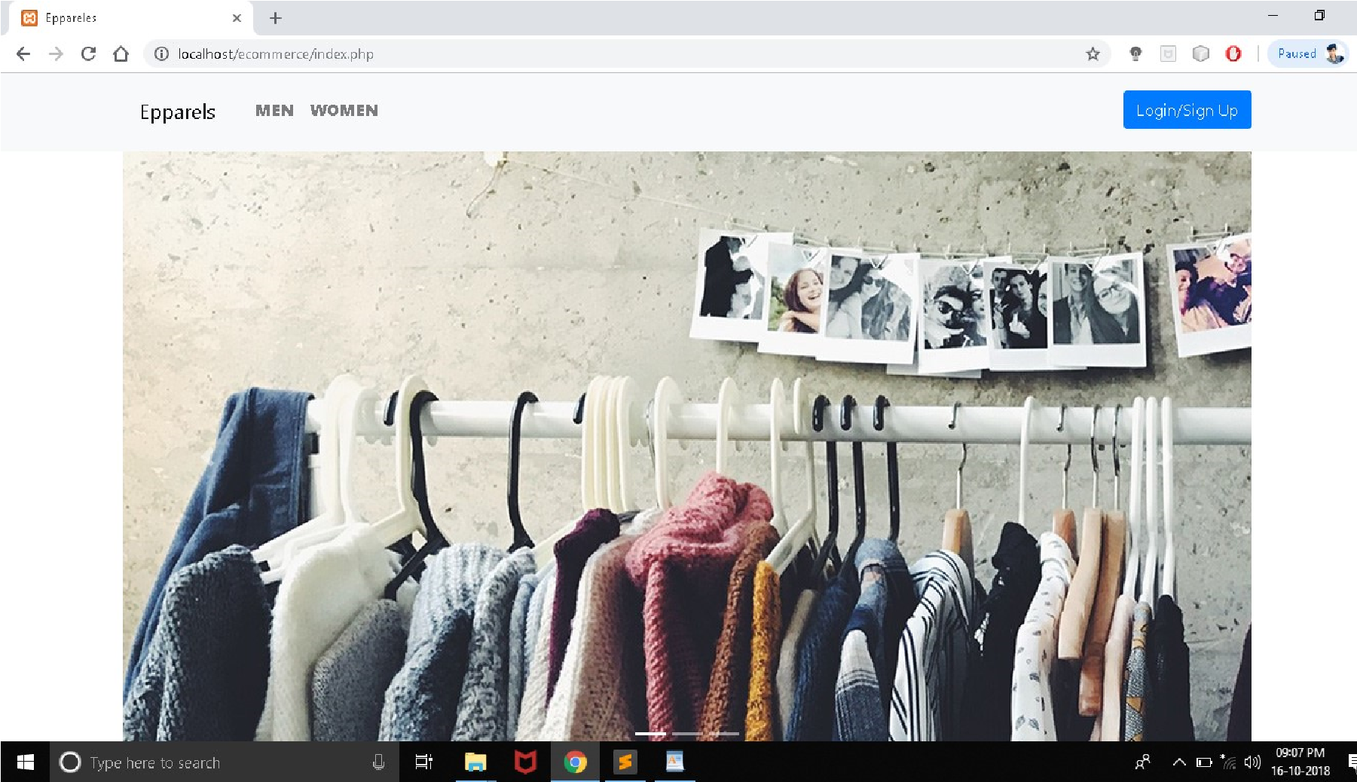

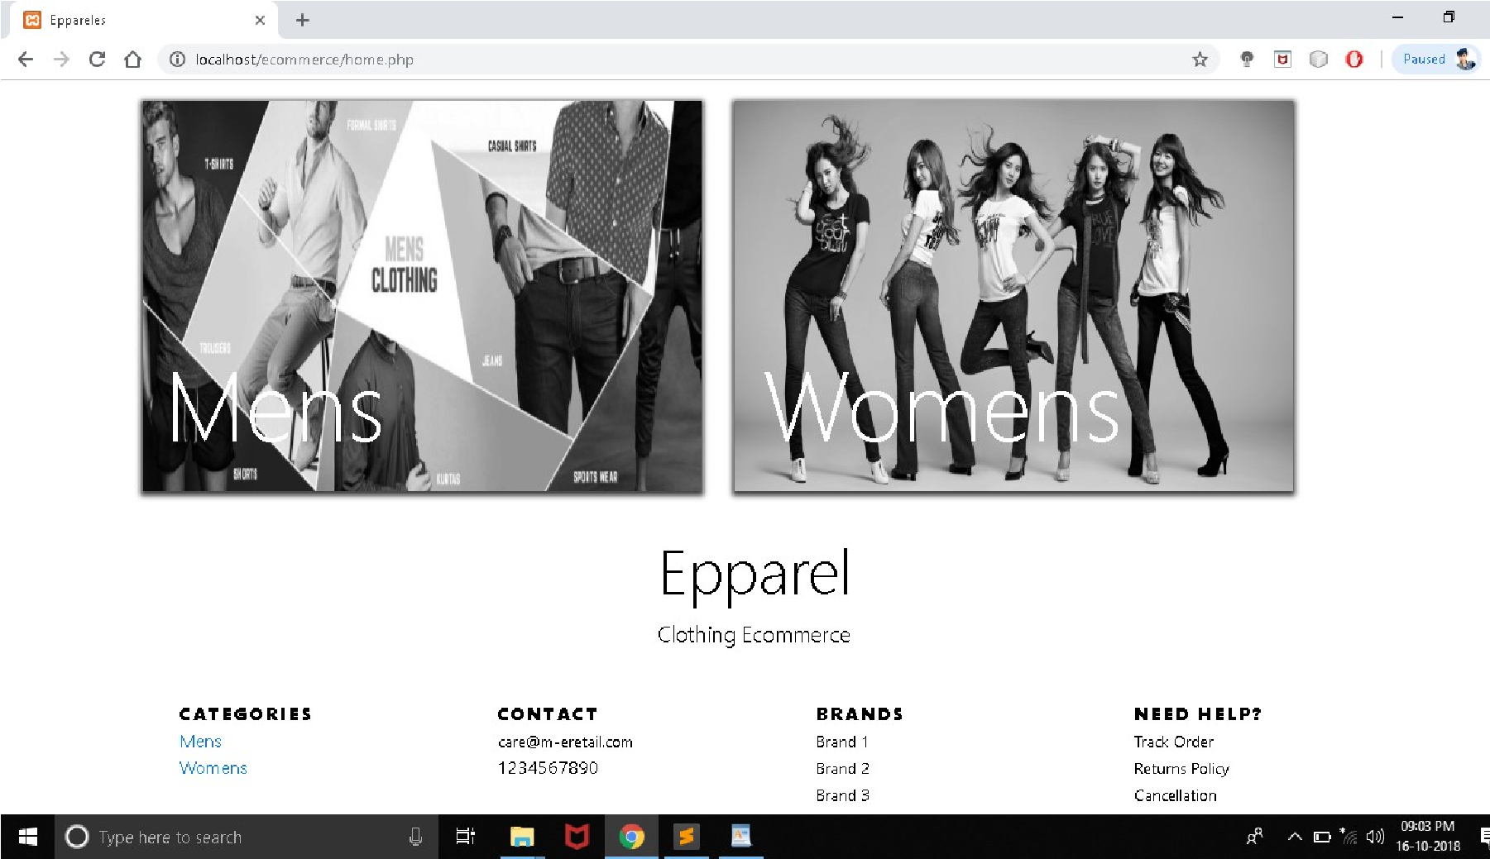

**mens-products.php**

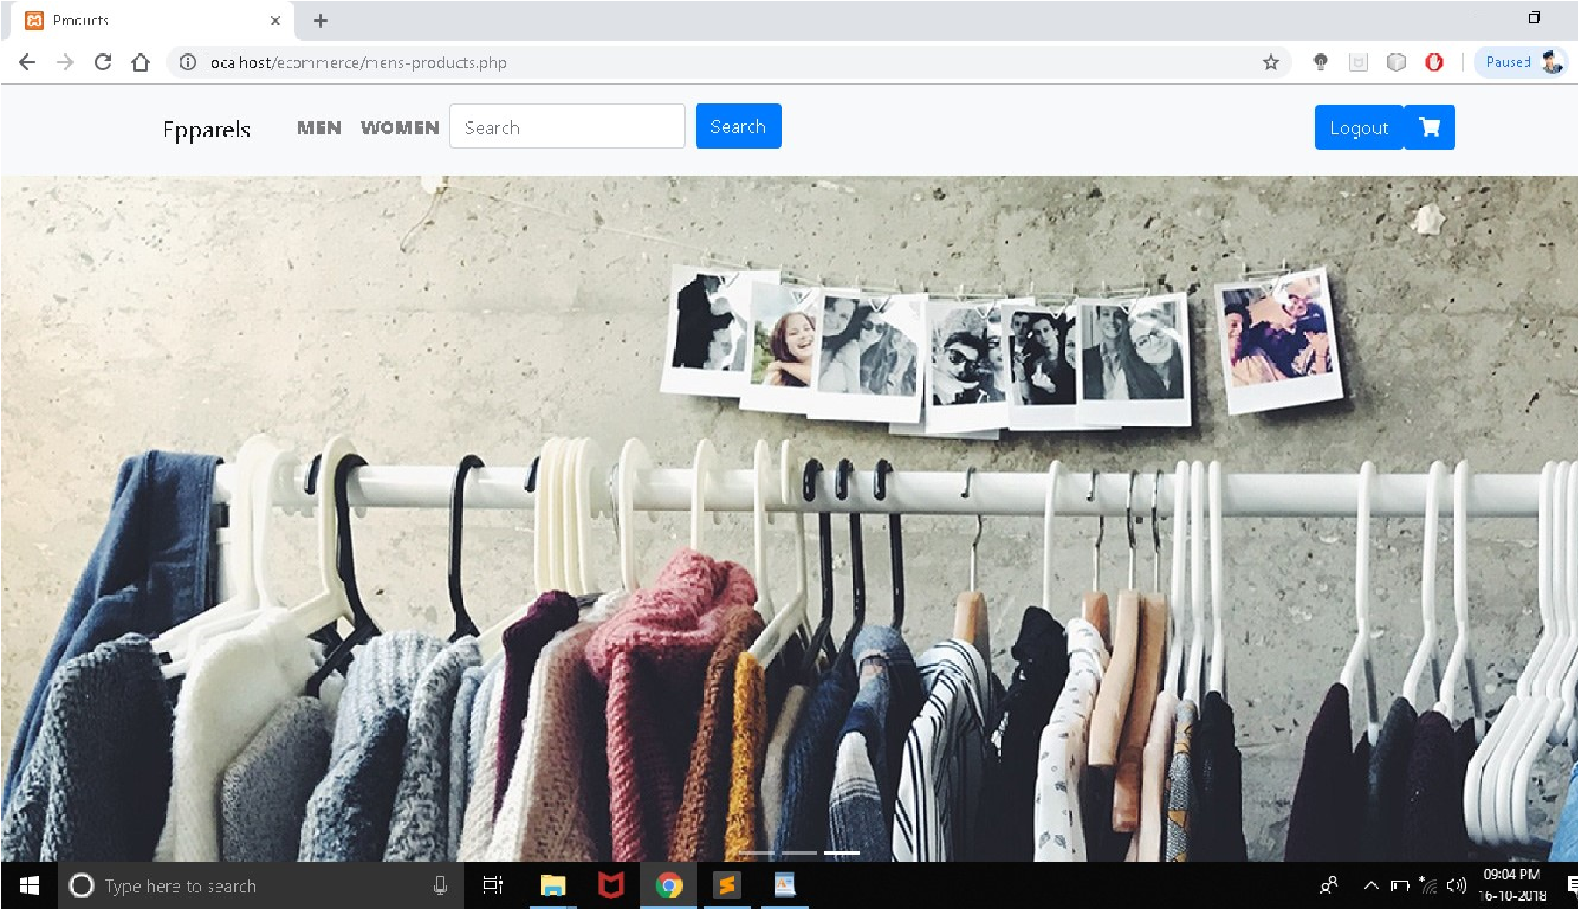

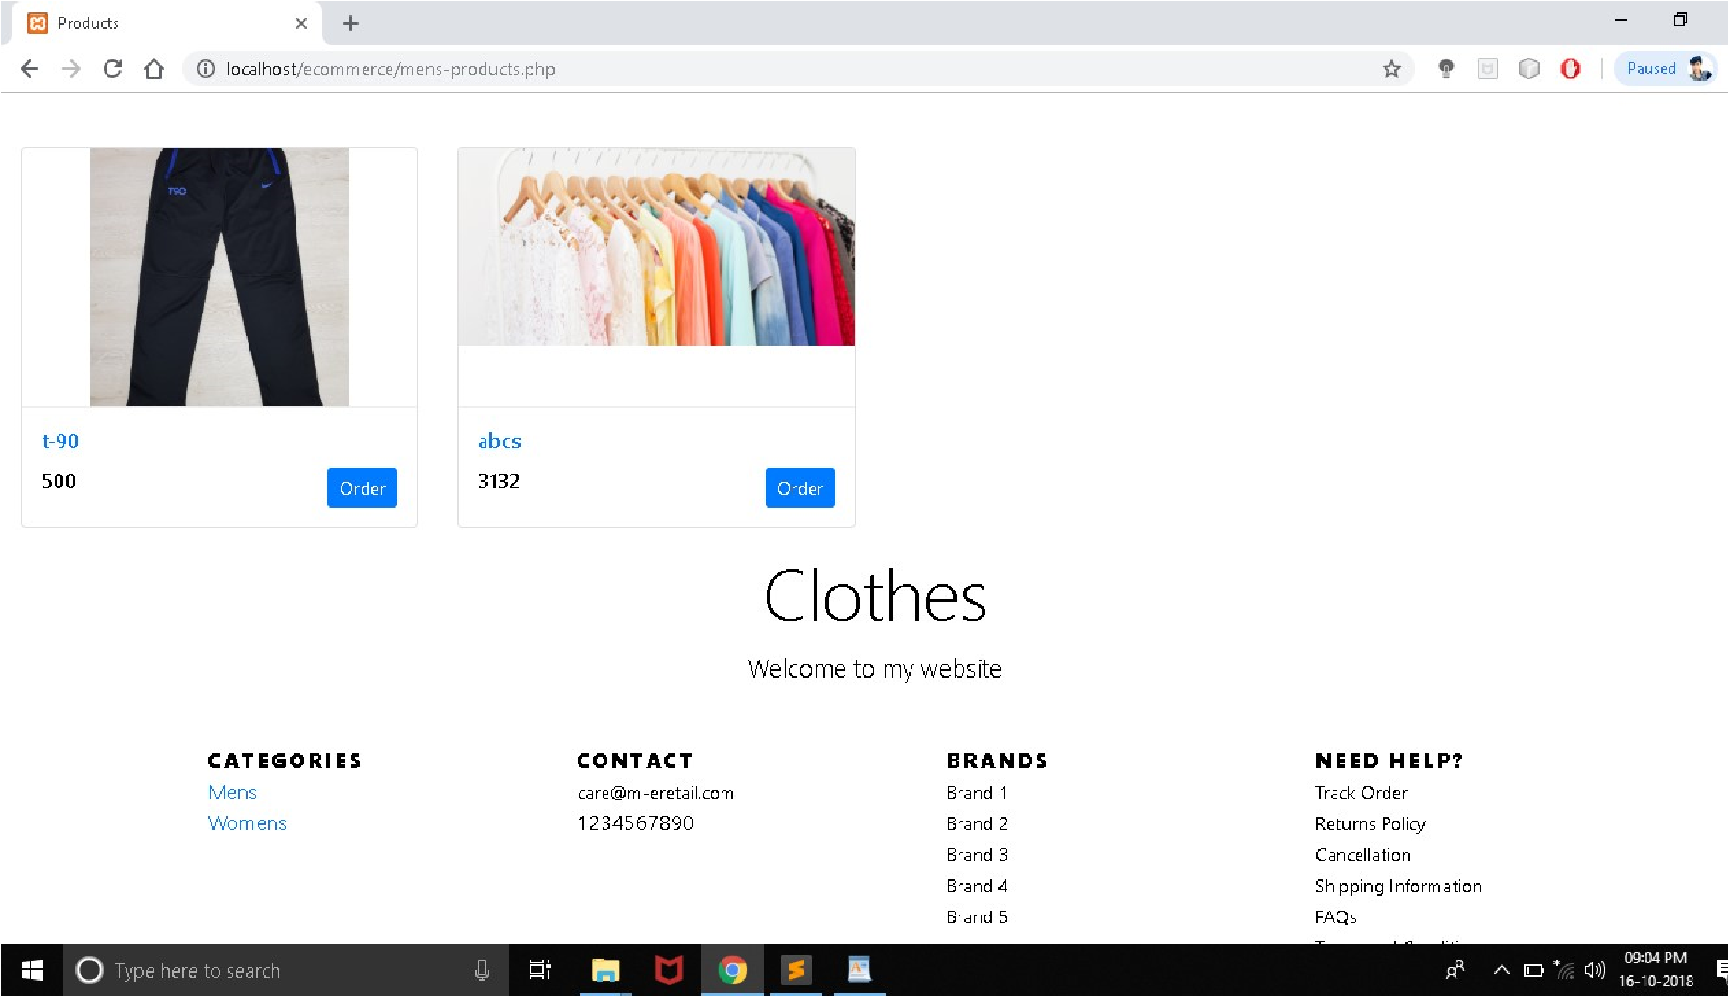

**womens-products.php**

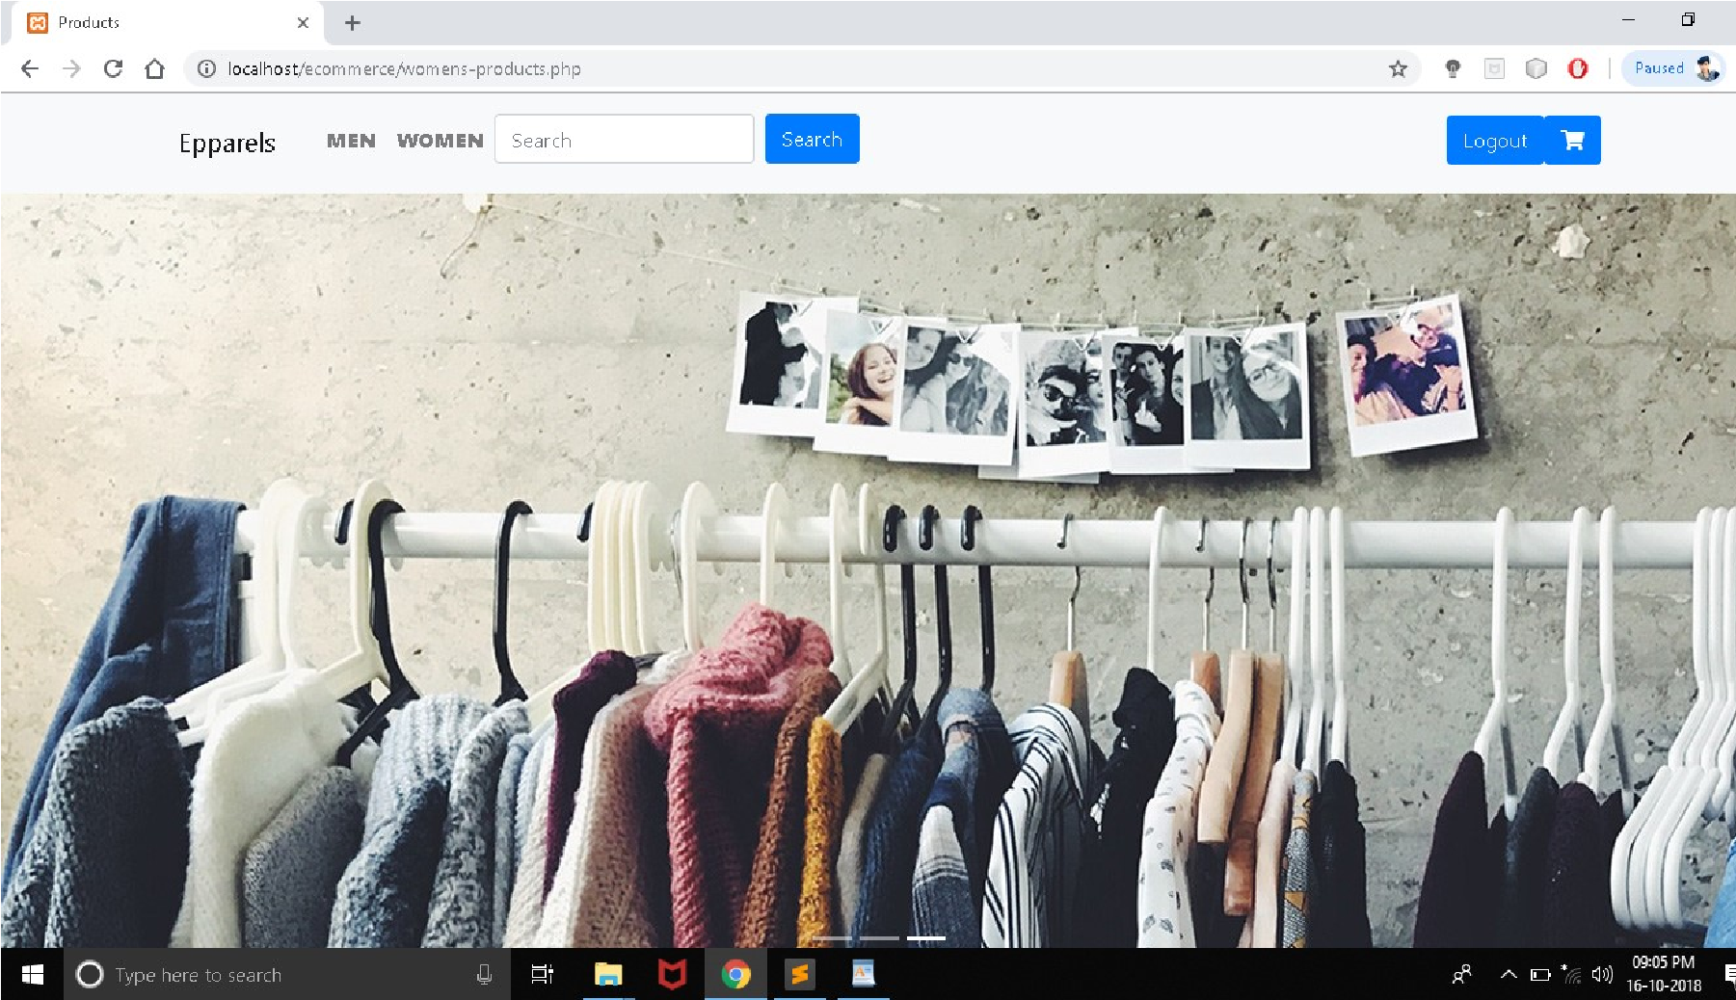

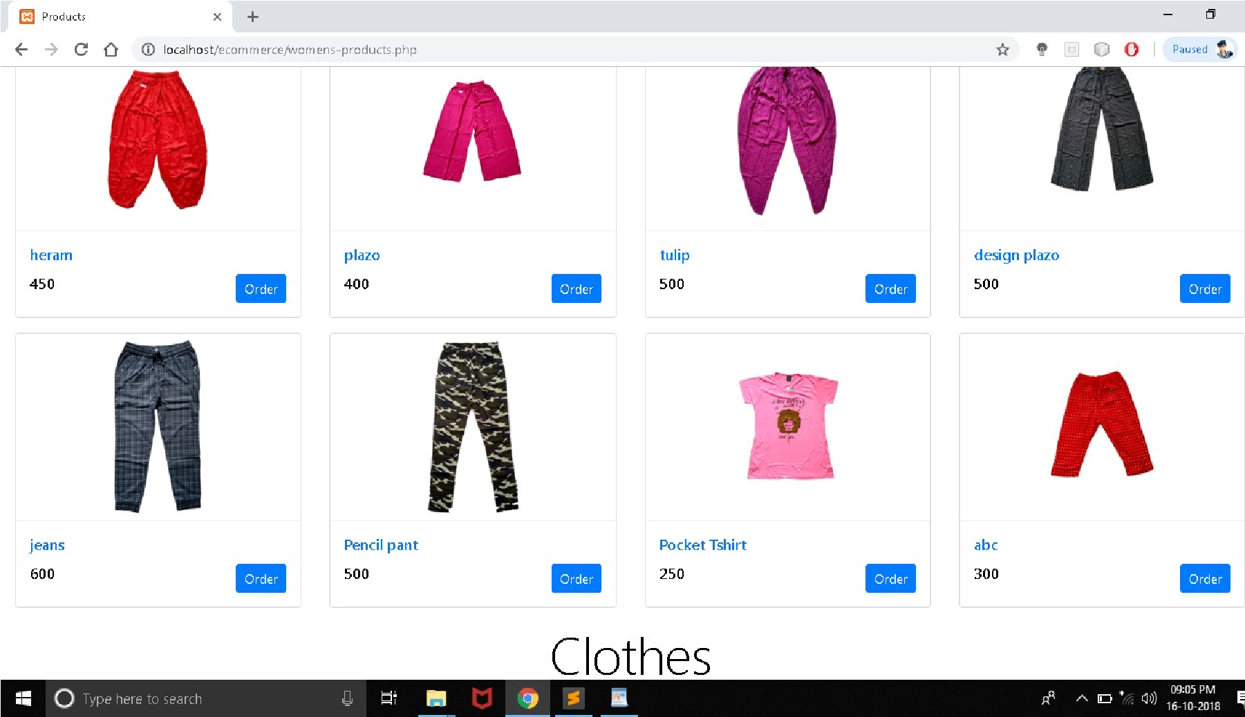

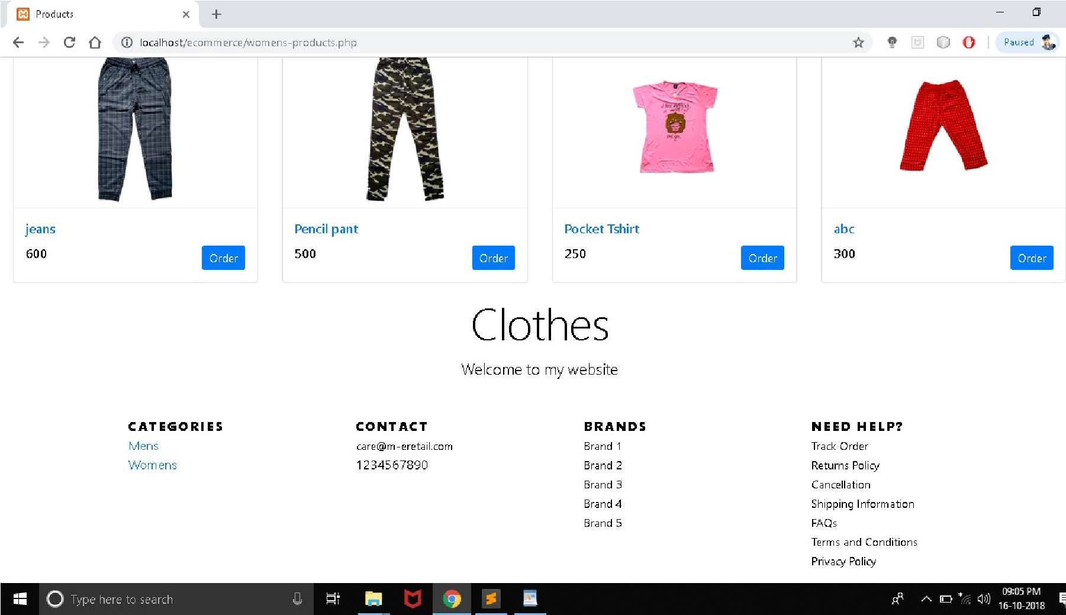

**b.php**

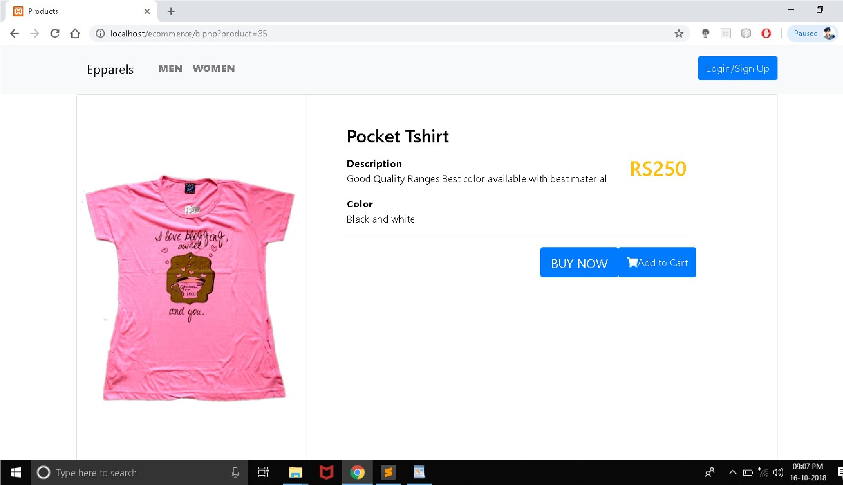

**login.php**

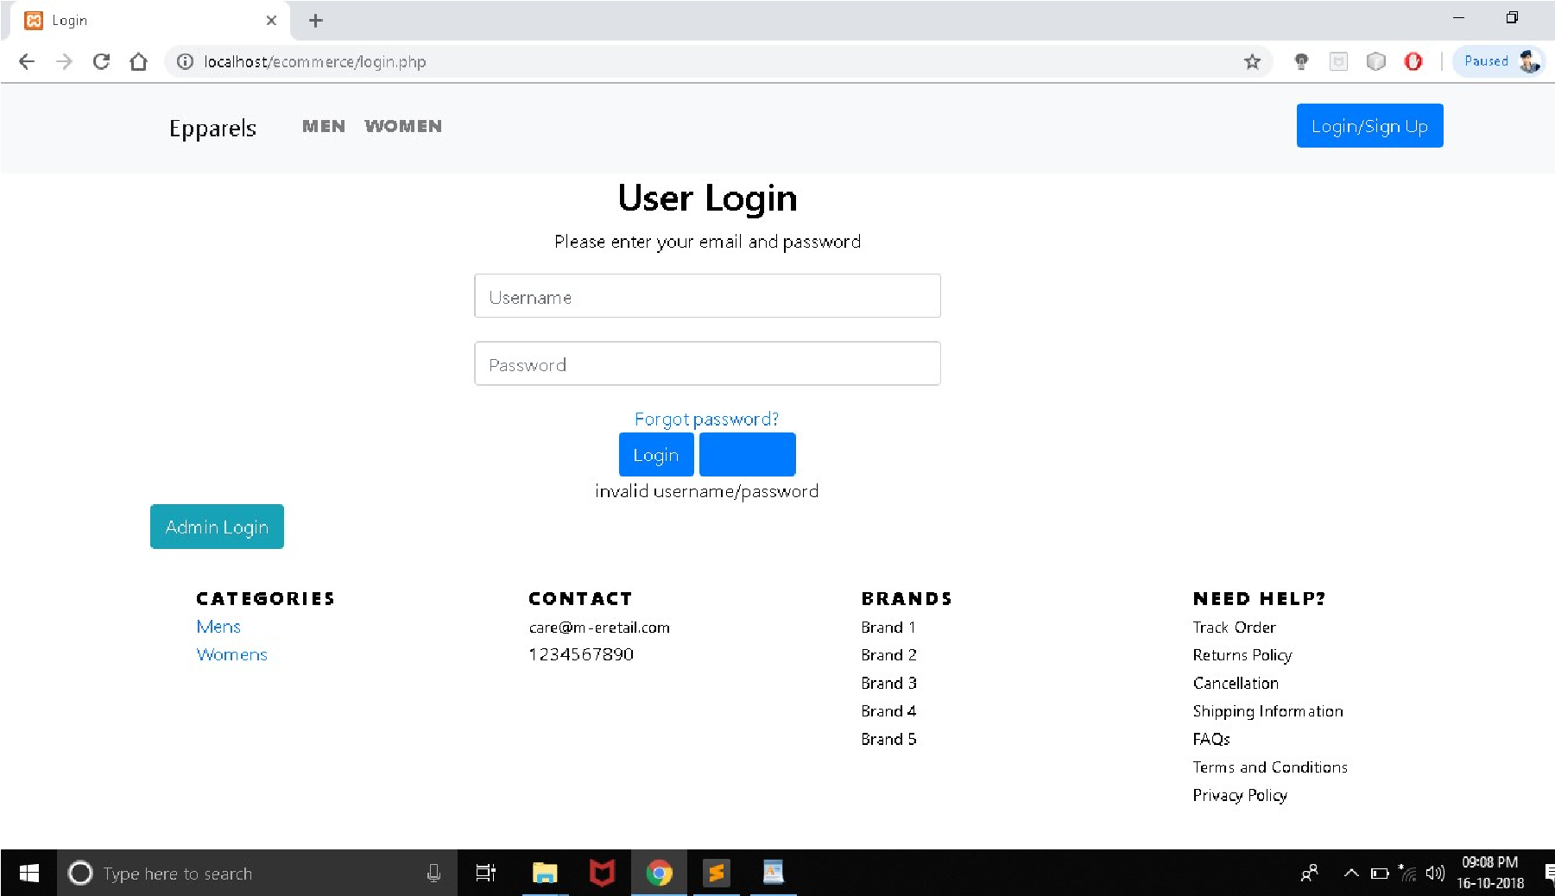

**adminlogin.php**

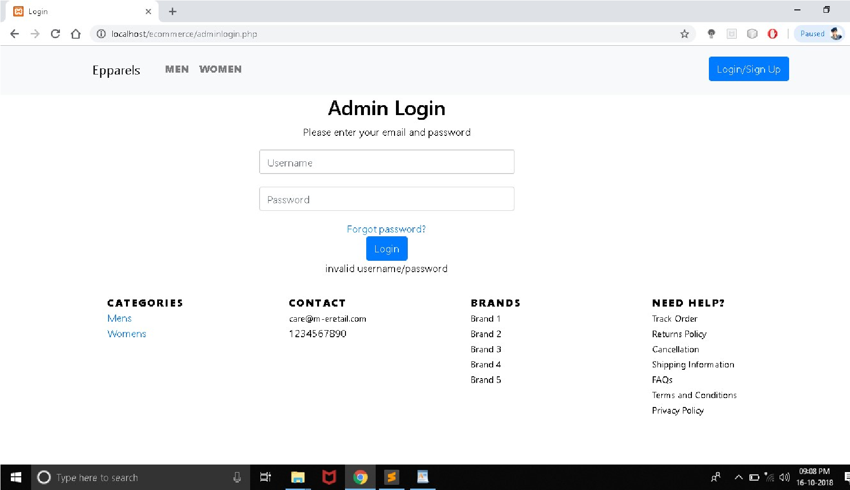

**register.php**

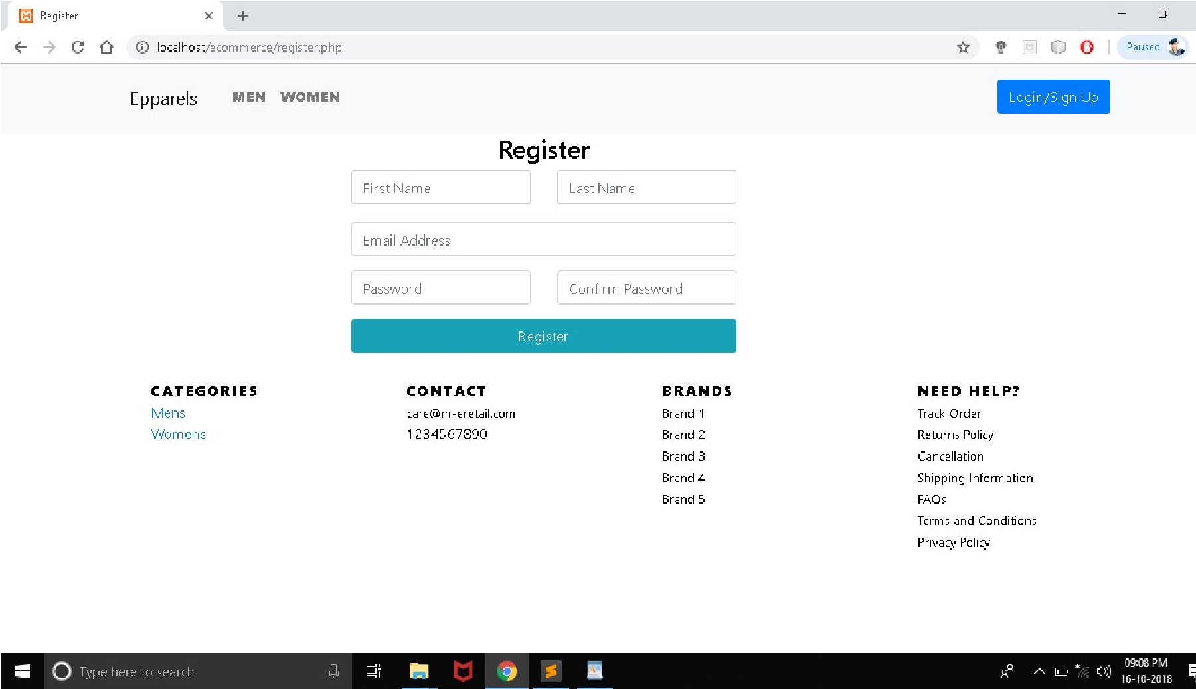

**insert-product.php**

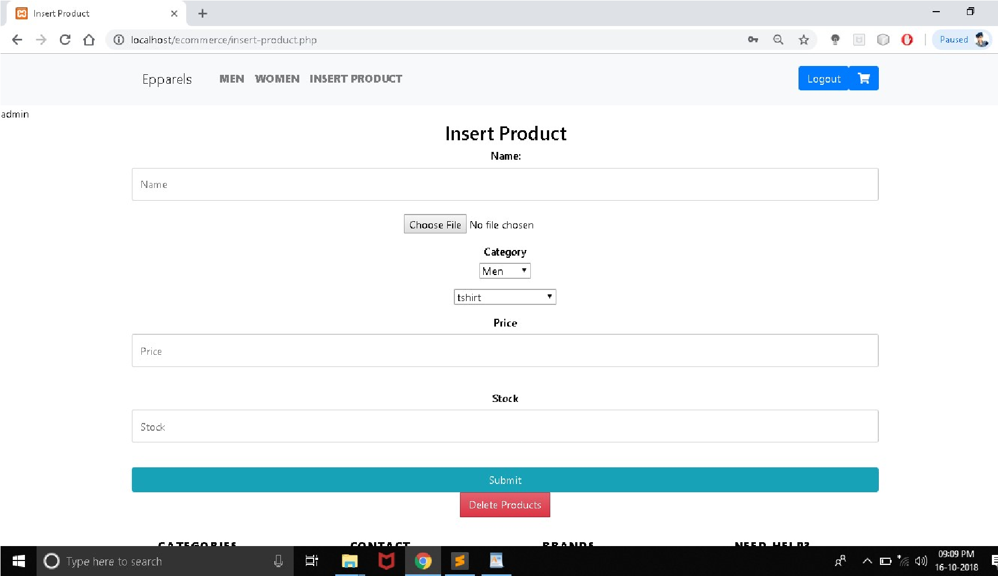

**deleteproduct.php**

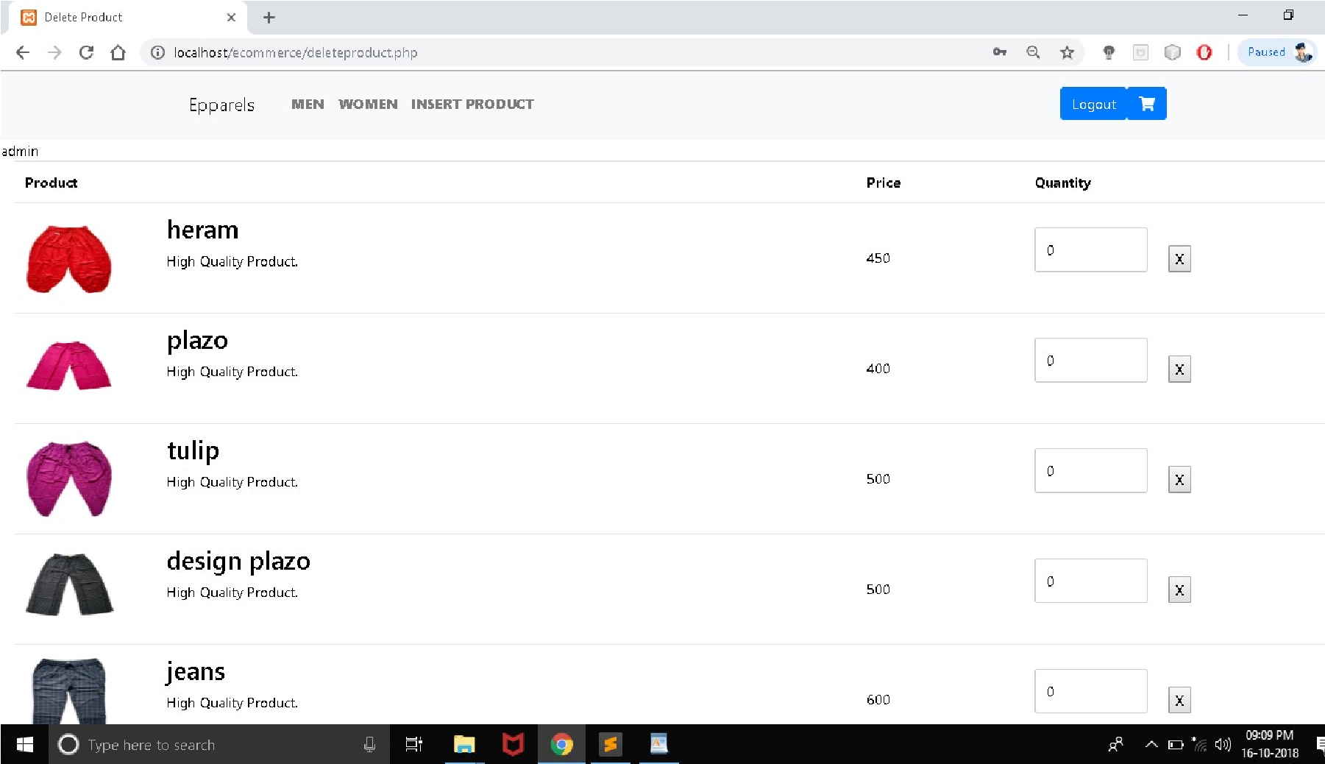

**newcart.php**

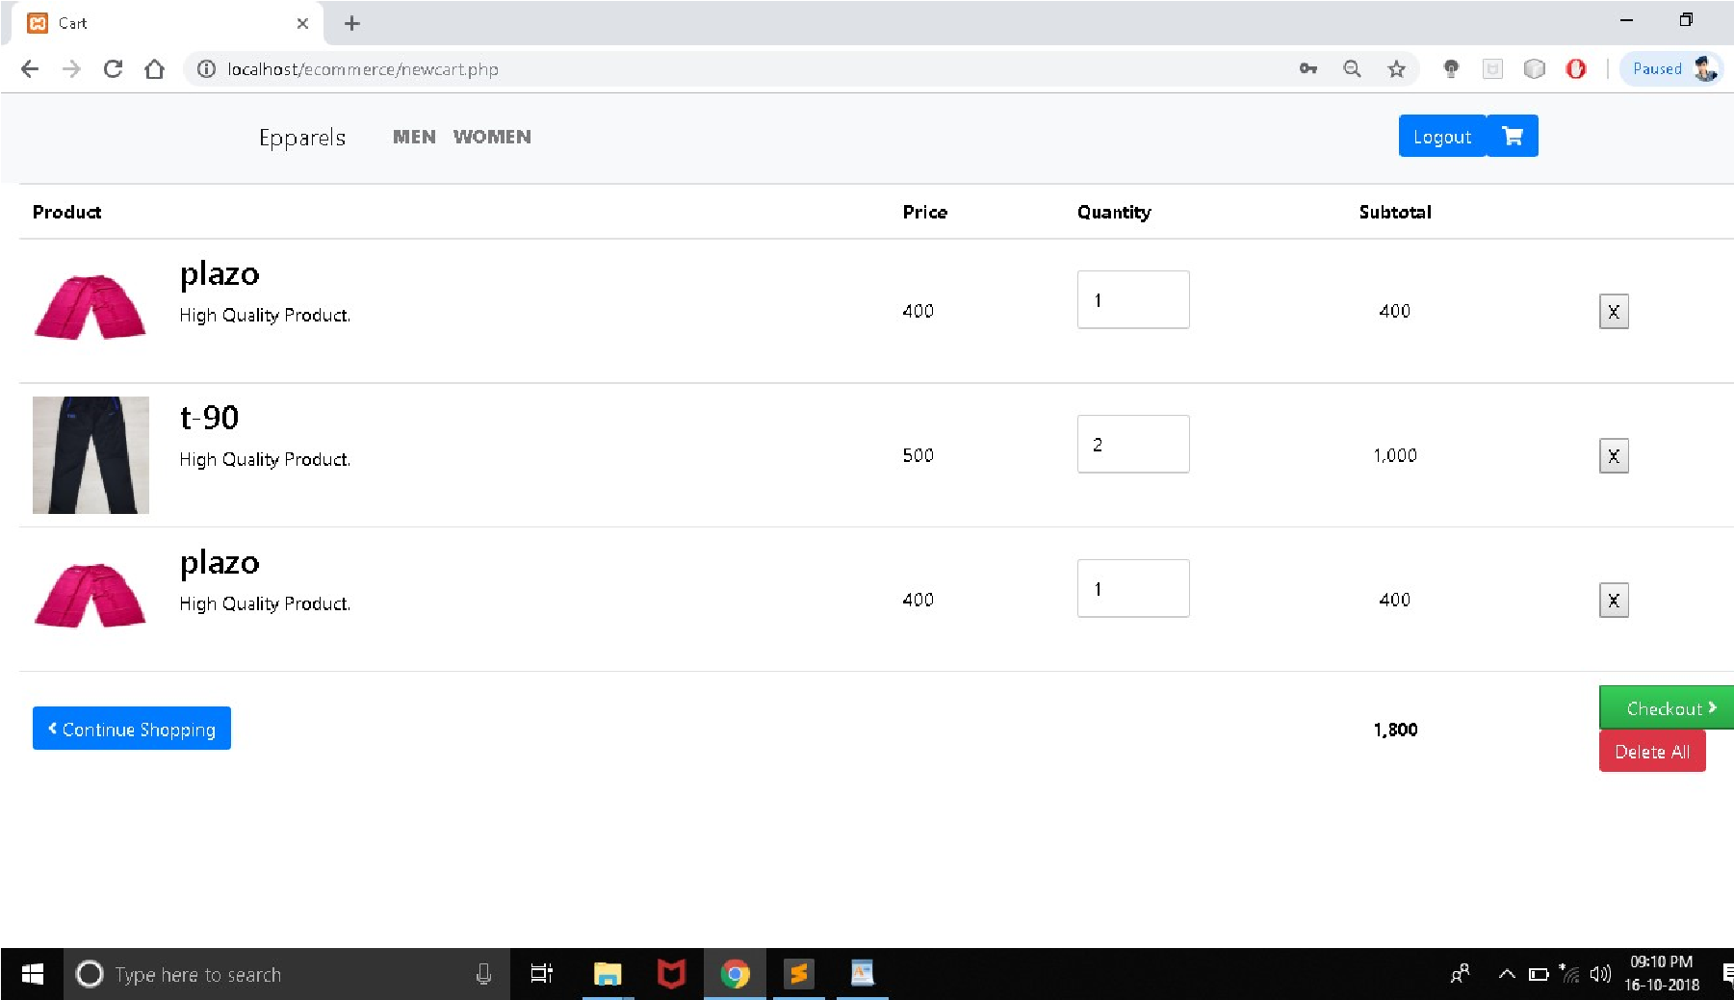

**checkout.php**

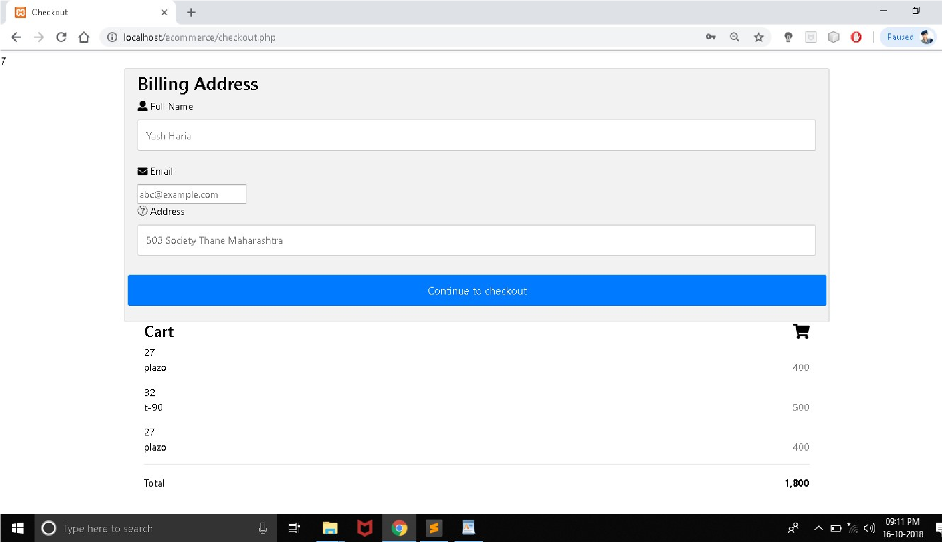

**Databases**

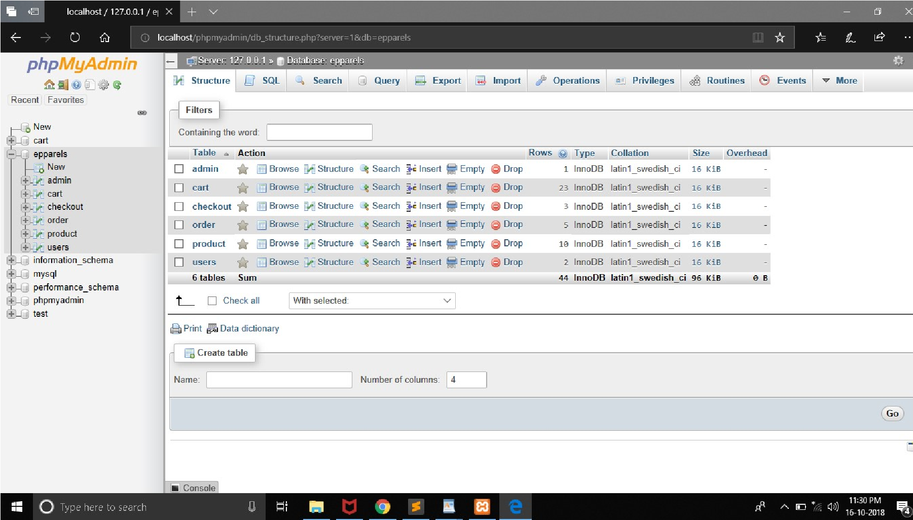

admin table

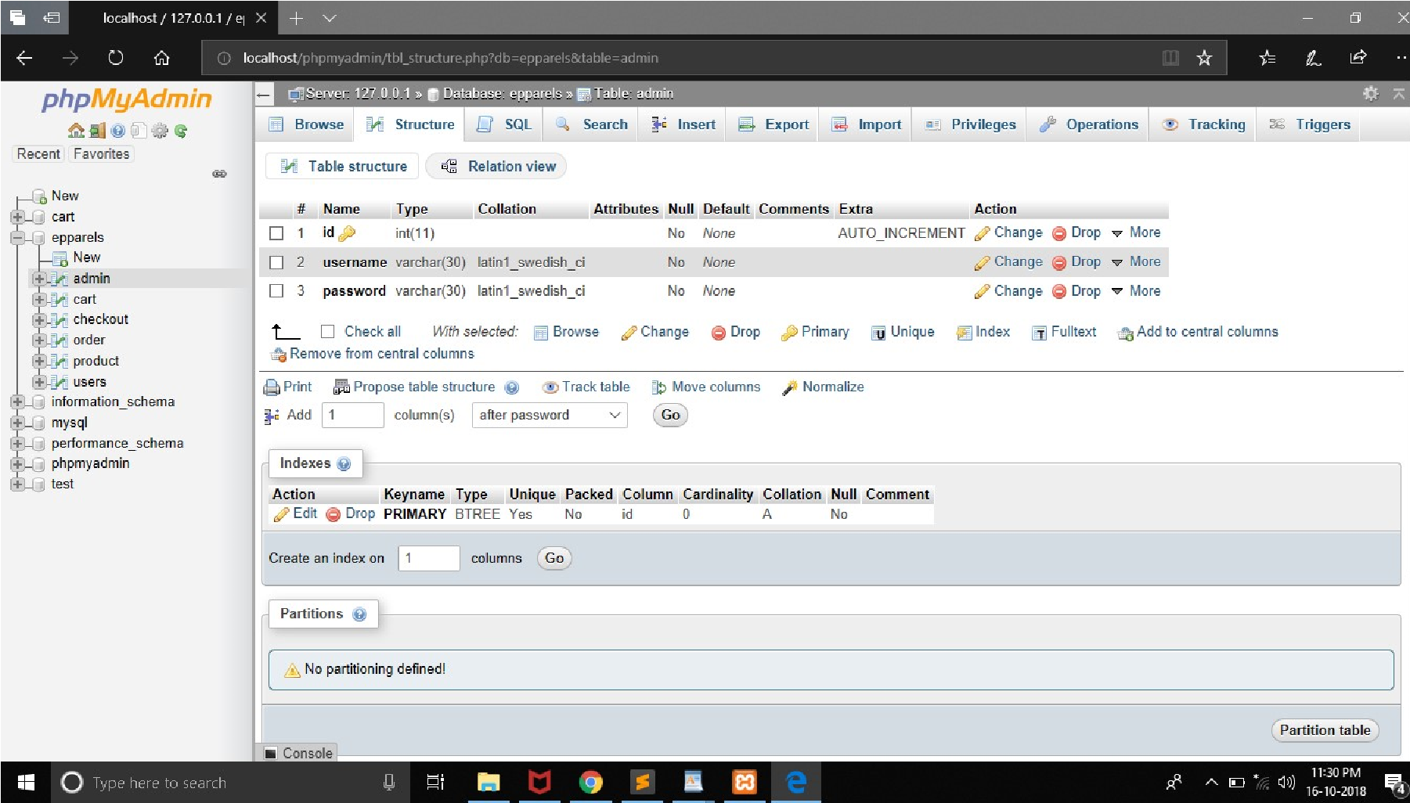

cart table

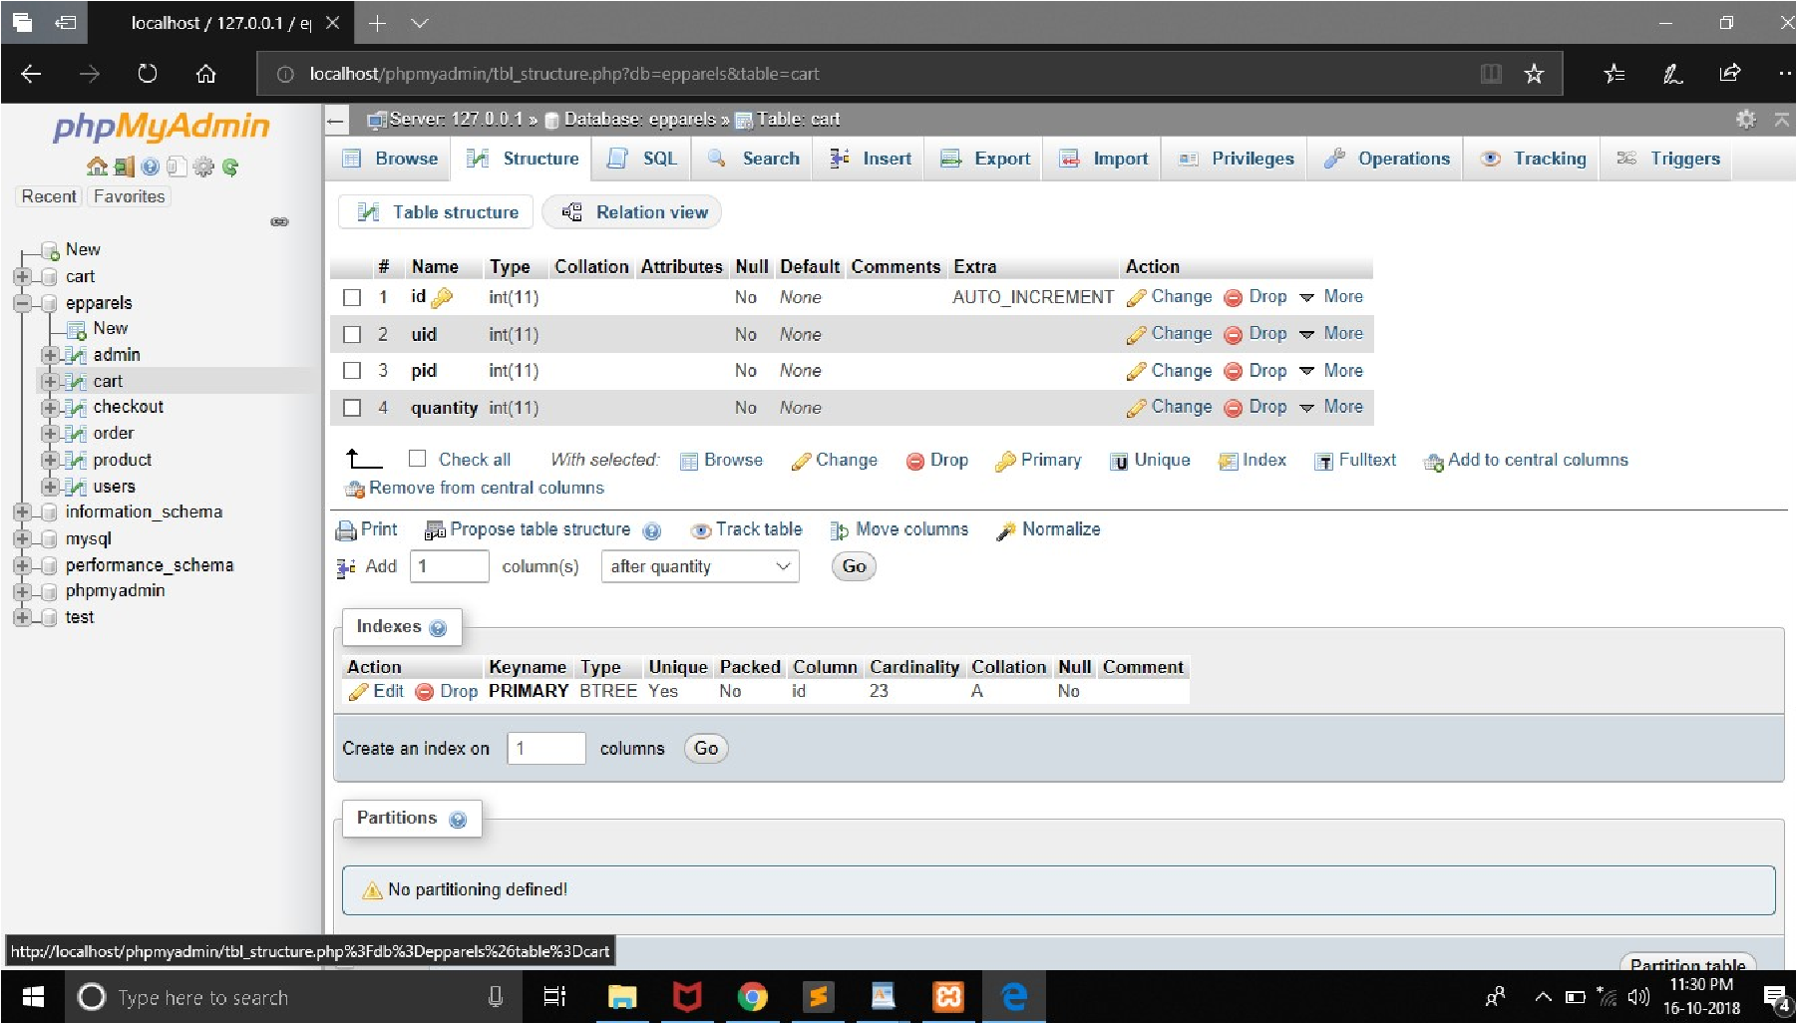

checkout table

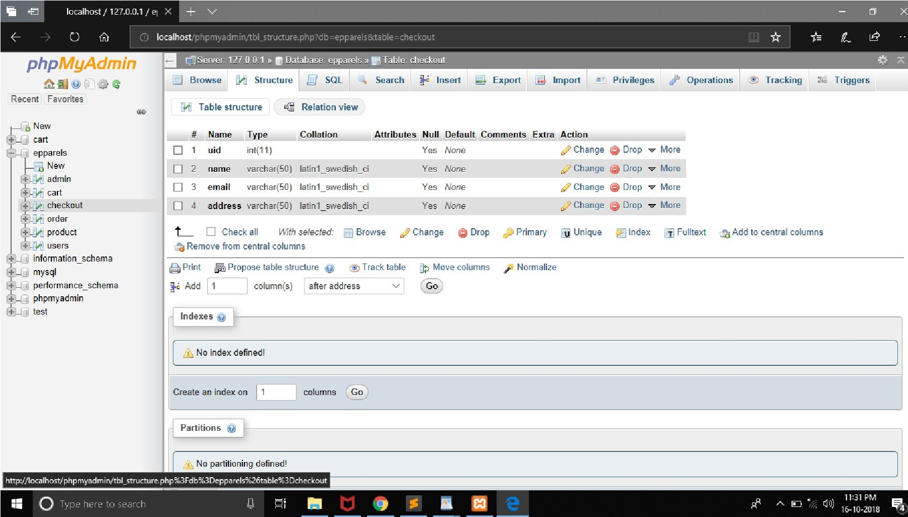

product table

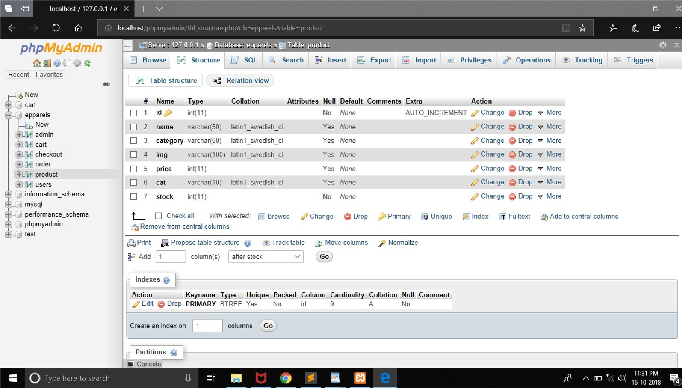

users table

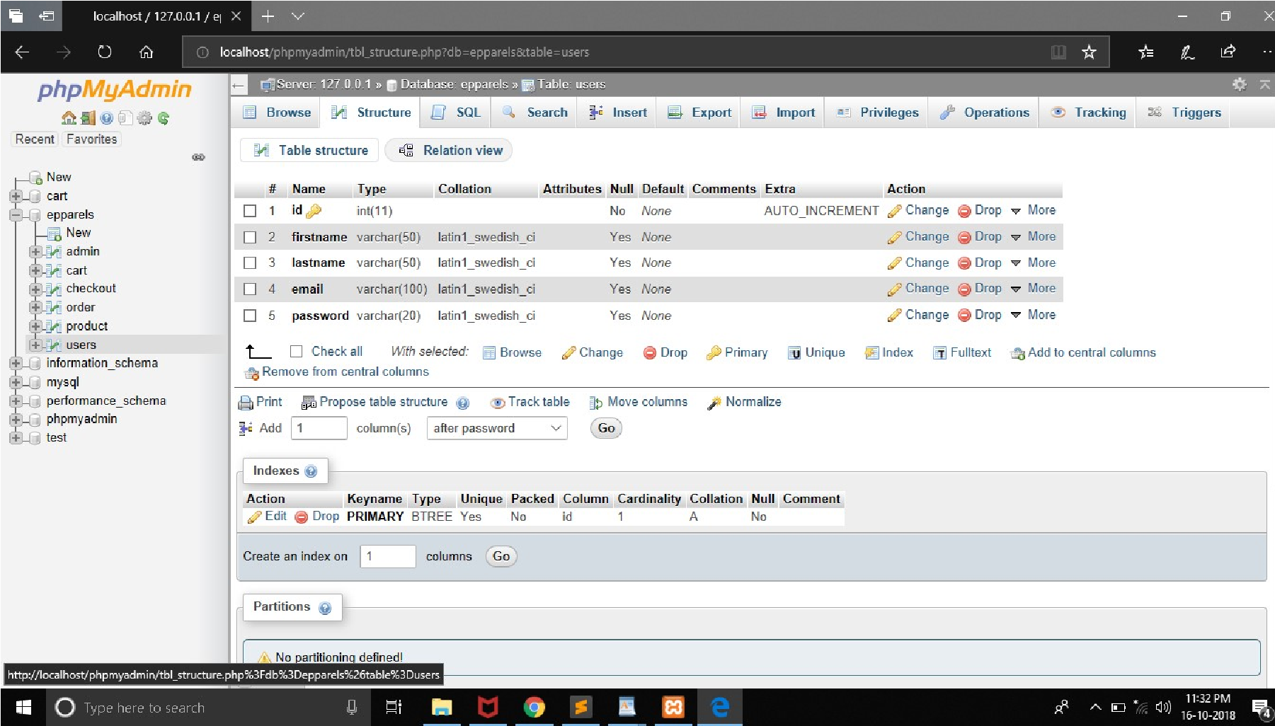

Bibliography

Web Reference :

⦁ www.google.com

⦁ www.youtube.com

⦁ www.bootstrap.com

⦁ www.w3schools.com